Bohr Model of the Atom page 90-93 Name _____________________________
1)Scientists constructed model of the atom using the information that they had gained through experiments. They knew, for example, that an atom has a densely ____________ _____________ that is ________________ charged.
2) What is inside the nucleus?  3) Why would it be charged at all?  4) What’s outside the nucleus?  5) What is the charge outside the nucleus? | 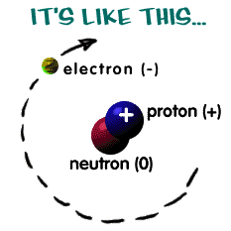
6) Scientists knew that any model of the atom may have to be modified or ____________ as new information was found. The Rutherford model was replaced by a model developed by ___________, that describes the electrons in terms of their ____________ _________________.
7) According to Bohr, electrons can only be ____________ ______________ from the nucleus.  **NOTE: shells = energy levels  8) Each distance corresponds to ________ __________________________________  __________________________________  close to the nucleus= _________________  farther from the nucleus= _____________  9) The difference in ___________ between two levels is known as a ________________ of energy, and these are the discrete units in which energy exists. |  | 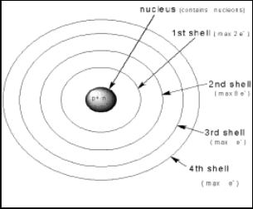
10) Which of the lettered diagrams below represents a Bohr model of an atom? |  |  | 11) The __________ _________  can be compared to rungs of a  ladder.
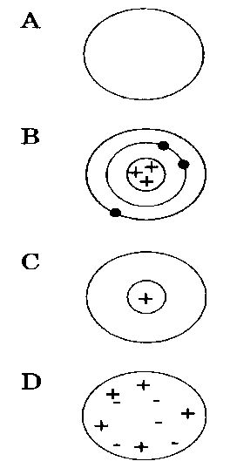 |  |  | 12) On the first rung, that  represents the ___________  ______________ ____________.  13) A person cannot stand  ______________ the rungs  on the ladder and likewise the electrons cannot have a  continuous range of __________.  14) Bohr’s model states that  the ___________ can only be  in one _________ ________  or another, not ____________.
15) Bohr also concluded that an electron did not _____________________________________ while in a given energy level.
ELECTRONS ACT LIKE BOTH PARTICLES AND WAVES page 91
16) In 1924, de Broglie pointed out that the behavior of electrons _______________________ ___________________________________. This is called the Wave-Particle Duality of Electrons.
17) Scientists knew that any ________ confined in space can have only certain _______________.
18) De Broglie suggested that _____________ could be considered ______________ confined to a space ________________________________ and therefore only have certain ________________.
19) These ___________________ correspond to the specific ____________ ________________ where the electrons are found.
20) The present day model of the atom takes into account both the ________________ and the _______ properties of the electrons. According to this model the electrons are found in _____________.
21) From the definition above figure 17 page 91 An ____________________ is a region in an atom where there is a high __________________________________________________________________.
22) __________________ are sometimes called electron clouds and they correspond to specific energy levels. Note that electron clouds do not have sharp __________________ because it only shows where the electrons are most _________________to be found. The text uses an analogy of the spinning _________________ of a ___________ because you cannot tell where any one ______________ is at a particular __________________.
Turn to page 93
23) The visible spectrum (which is the light we can see) is only a tiny______________________ _________________________________________________.
24) The __________________________________ includes X-rays, ultraviolet and infrared light, microwaves, gamma and radio waves as well as visible light. Each of these waves is referred to as ____________ although we cannot see these ___________________________.
Use your Chemistry Reference Tables to find the correct arrangement of the waves in bold-faced print in #24. Now, arrange these waves from lowest frequency (longest wavelength) to highest frequency (shortest wavelength)
_________> ___________>___________>____________>___________>___________>_________
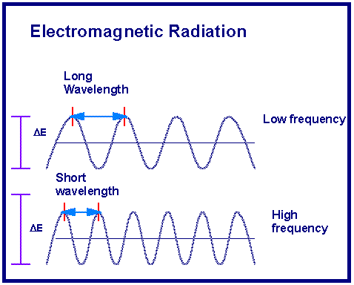 | Please note: figure 19 page 93  The wavelength is the distance between waves and the frequency of the waves is how many wave cycles pass a certain point per unit of time.  Wavelength and frequency have a  ( direct / inverse ) relationship.  ΔE is the Energy and it has a direct relationship with frequency.

25) When an electric current is passed through a tube of hydrogen gas, a _________________-colored ______________ is seen.
26) A spectrum of only a few colors is called a __________--_______________ ______________.
Experiments with other gases have shown that _________ ____________ has its own unique different pattern of colors in its ____________-- _________________ __________________.
27) In 1913 Bohr showed that hydrogen’s electron can move from a low ___________ _________ to a higher ______________ ________________ by _____________________ energy. Note: the lowest energy level an electron can occupy is called the GROUND STATE.
28) Electrons at a higher energy level are said to be in the EXCITED STATE and they are _____________ so they move to a _______________ energy level by ________________ energy.
29) The energy is __________________ in the form of light that has a specific _______________. This means it also has a frequency that matches a type of light on the electromagnetic (EM) spectrum but it may not appear as a color we can see with our eyes.
30) Each time an electron moves from a particular energy level to a ____________ energy level, it will __________________ light of a ________________ __________________.
Completion- demonstrate your understanding of Bohr’s model of the atom by using the word bank to complete the passage below.
ground state excited state higher lower
direct inverse spectrum nucleus
electrons releases absorbing Niels Bohr
quanta probability clouds Wave/particle duality
1. The atom has a positive region called the _______________.
2. The negative particles are called ___________________.
3. The atom has fuzzy electron _____________ that correspond to specific energy levels.
4. An orbital is a region where there is a high __________________ of finding an electron.
5. When you take de Broglie and Bohr’s model together you can see that electrons exhibit _____________________________________.
6. Energy of moving electrons exists in discrete units called _____________. (plural form)
7. The lowest energy level an electron can occupy is called the __________ ____________.
8. An electron can move to a higher energy level, or the ___________ ___________, by ______________ energy.
9. The electron is unstable at a higher energy level and _________________ energy in a pattern of a few colors called a line-emission _________________.
10. ___________________ showed the relationship between the color of light emitted from electrified hydrogen gas and the movement of hydrogen’s electron.
11. There is a(n) _________________ relationship between wavelength and frequency and a(n) ________________________ relationship between energy and frequency of light.
12. When an electron gains energy, it moves from the ground state to a _____________ energy level.
13. The electron releases an amount of energy equal to the difference in energy levels (on an emission spectrum) when it moves to a _______________ energy level
Use your Chemistry Reference Tables to determine the type of light emitted in each of these transitions:
Transition from energy levels  energy level = (n) | wavelength of light in nm  nanometers = 10⁻⁹ m | portion of EM spectrum emitted  IR, UV, or visible
n=4 to n=3 | 1875 nm | infrared
n= 3 to n=1
 | 656 nm
n=5 to n=3
 | 97 nm
n= 6 to n= 2
 | 486 nm
n= 2 to n=1
 | 1094 nm
NOTE: 580 nanometers is the same as 580 x 10⁻⁹ m
In proper scientific notation that would be 5.8 x 10⁻⁷ m. Use the EM Spectrum from your Reference Tables to verify that this is yellow light on the visible spectrum.
Complete the table below to show your understanding of the visible light portion of the EM spectrum
wavelength in nanometers | wavelength in meters | color of visible light | transition  (if given)
580 nm | 5.8 x 10⁻⁷ m | yellow | ? n=2
410 nm
656 nm
486 nm
434 nm
 | 4.2 x 10 ⁻⁷ m
 | 5.1 x 10 ⁻⁷ m

