18.1 Ecosystems

Lesson Objectives
- Define ecosystem, and give examples.
- Identify abiotic factors in ecosystems.
- Describe biotic factors in ecosystems.
- Explain how energy flows through ecosystems.
- Outline how matter moves through ecosystems.

Vocabulary
- abiotic factor
- biotic factor
- carnivore
- community
- consumer
- decomposer
- ecosystem
- food chain
- food web
- grazer
- habitat
- herbivore
- niche
- nutrients
- omnivore
- population
- predator
- prey
- producer
- scavenger
- species

Introduction
You open your front door and step outside. It doesn’t matter where you live, you are in your ecosystem. All around you are living and nonliving things. You’re surrounded by air. You feel warm sunlight on your face. There’s soil under your feet. You see plants and hear a bird singing. Your own body is covered with billions of bacteria. All of these things are part of your ecosystem.

What Is an Ecosystem?
An ecosystem is a group of living things and their environment. The word ecosystem is short for “ecological system.” Like any system, an ecosystem is a group of parts that work together. You can see examples of ecosystems in Figure below. The forest pictured is a big ecosystem. Besides trees, what living things do you think are part of the forest ecosystem? The dead tree stump in the same forest is a small ecosystem. It includes plants, mosses, and fungi. It also includes insects and worms.
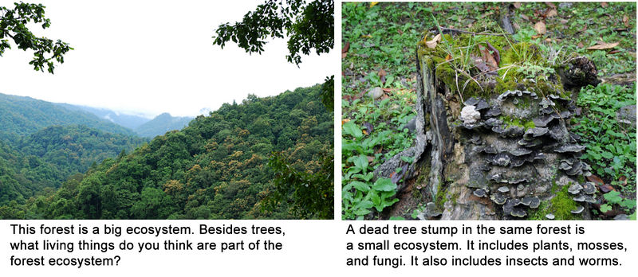
An ecosystem can be big or small. A small ecosystem can be part of a larger ecosystem.

Abiotic Factors
Abiotic factors are the nonliving parts of ecosystems. They include air, sunlight, soil, water, and minerals. These are all things that are needed for life. They determine which living things — and how many of them — an ecosystem can support. Figure below shows an ecosystem and its abiotic factors.
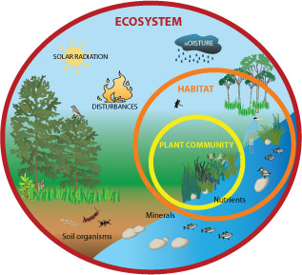
Which abiotic factors do you see here?

Biotic Factors
Biotic factors are the living parts of ecosystems. They are the species of living things that reside together.

Species, Niche, and Habitat
A species is a unique type of organism. Members of a species can interbreed and produce offspring that can breed (they are fertile). Organisms that are not in the same species cannot do this. Examples of species include humans, lions, and redwood trees. Can you name other examples?
Each species has a particular way of making a living. This is called its niche. You can see the niche of a lion in Figure below. A lion makes its living by hunting and eating other animals. Each species also has a certain place where it is best suited to live. This is called its habitat. The lion’s habitat is a grassland. Why is a lion better off in a grassland than in a forest?
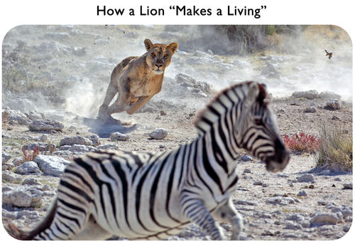
[Figure 1]
A lion hunts a water buffalo. What is the water buffalo’s niche?

Living Together
All the members of a species that live in the same area form a population. Many different species live together in an ecosystem. All their populations make up a community. What populations live together in the grassland in Figure above?

Roles in Ecosystems
All ecosystems have living things that play the same basic roles. Some organisms must be producers. Others must be consumers. Decomposers are also important.

Producers
Producers are living things that use energy to make food. Producers make food for themselves and other living things. There are two types of producers:
- By far the most common producers use the energy in sunlight to make food. This is called photosynthesis. Producers that photosynthesize include plants and algae. These organisms must live where there is plenty of sunlight. Which living things are producers in Figure above?
- Other producers use the energy in chemicals to make food. This is called chemosynthesis. Only a very few producers are of this type, and all of them are microbes. These producers live deep under the ocean where there is no sunlight. You can see an example in Figure below.
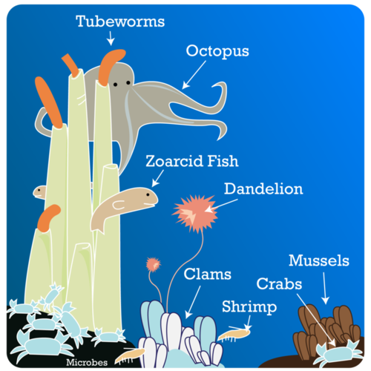
Microbes use chemicals to make food. The chemicals pour out of a crack on the ocean floor at a mid-ocean ridge. What consumers live in this ecosystem?

Consumers
Consumers can’t make their own food. Consumers must eat producers or other consumers. Figure below lists the three main types of consumers. Which type are you?
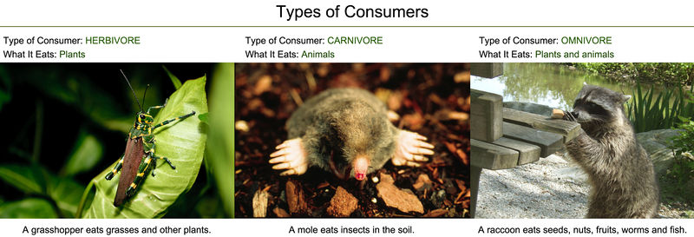
Examples of the main types of consumers. Can you name other consumers of each type?
Consumers get their food in different ways Figure below. Grazers feed on living organisms without killing them. A rabbit nibbles on leaves and a mosquito sucks a drop of blood. Predators, like lions, capture and kill animals for food. The animals they eat are called prey. Even some plants are consumers. Pitcher plants trap insects in their sticky fluid in their “pitchers.” The insects are their prey. Scavengers eat animals that are already dead. This hyena is eating the remains of a lion’s prey. Decomposers break down dead organisms and the wastes of living things. This dung beetle is rolling a ball of dung (animal waste) back to its nest. The beetle will use the dung to feed its young. The mushrooms pictured are growing on a dead log. They will slowly break it down. This releases its nutrients to the soil.
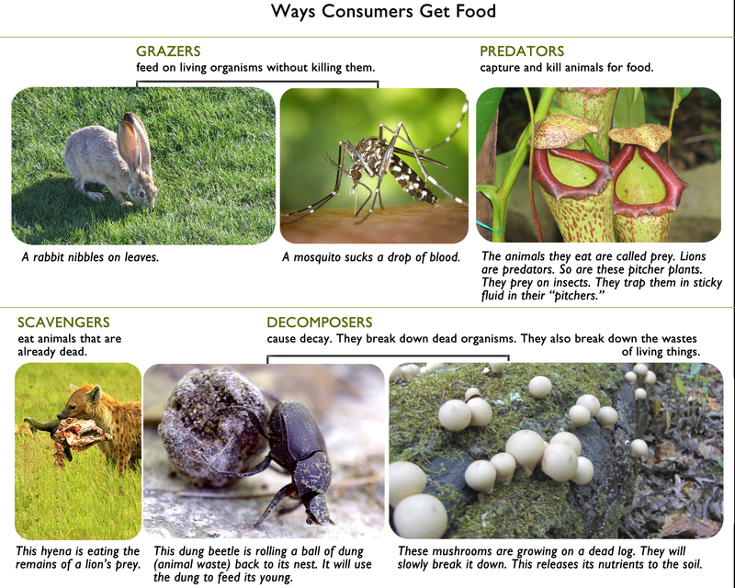
Ways consumers get food. Do you know how earthworms get food?

How Energy Flows Through Ecosystems
All living things need energy. They need it to power the processes of life. For example, it takes energy to grow. It also takes energy to produce offspring. In fact, it takes energy just to stay alive. Remember that energy can’t be created or destroyed. It can only change form. Energy changes form as it moves through ecosystems.

The Flow of Energy
Most ecosystems get their energy from the Sun. Only producers can use sunlight to make usable energy. Producers convert the sunlight into chemical energy or food. Consumers get some of that energy when they eat producers. They also pass some of the energy on to other consumers when they are eaten. In this way, energy flows from one living thing to another.

Food Chains
A food chain is a simple diagram that shows one way energy flows through an ecosystem. You can see an example of a food chain in Figure below. Producers form the base of all food chains. The consumers that eat producers are called primary consumers. The consumers that eat primary consumers are secondary consumers. This chain can continue to multiple levels.
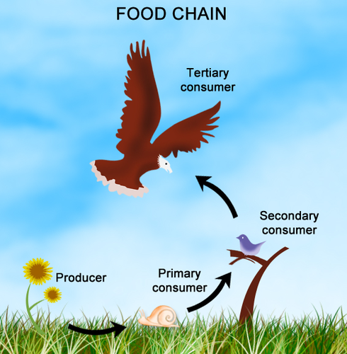
What do the arrows stand for in a food chain?
At each level of a food chain, a lot of energy is lost. Only about 10 percent of the energy passes to the next level. Where does that energy go? Some energy is given off as heat. Some energy goes into animal wastes. Energy also goes into growing things that another consumer can't eat, like fur. It's because so much energy is lost that most food chains have just a few levels. There’s not enough energy left for higher levels.

Food Webs
Food chains are too simple to represent the real world. They don’t show all the ways that energy flows through an ecosystem. A more complex diagram is called a food web. You can see an example in Figure below. A food web consists of many overlapping food chains. Can you identify the food chains in the figure? How many food chains include the mouse?
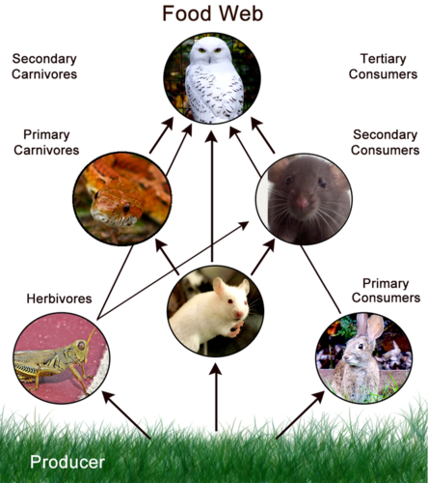
The owl in this food web consumes at two different levels. What are they?

How Matter Moves Through Ecosystems
Living things need nonliving matter as well as energy. What do you think matter is used for? One thing is to build bodies. They also need it to carry out the processes of life. Any nonliving matter that living things need is called a nutrient. Carbon and nitrogen are examples of nutrients. Unlike energy, matter is recycled in ecosystems. You can see how in Figure below.
- Decomposers release nutrients when they break down dead organisms.
- The nutrients are taken up by plants through their roots.
- The nutrients pass to primary consumers when they eat the plants.
- The nutrients pass to higher level consumers when they eat lower level consumers.
- When living things die, the cycle repeats.
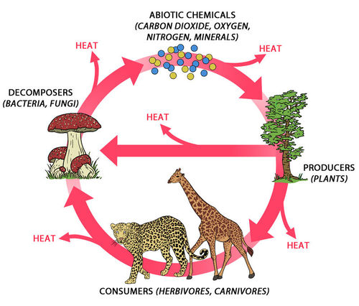
This diagram shows two cycles. One is the cycle of energy, the other is the cycle of matter. Compare the two cycles. Do you see how the Sun keeps adding energy? That’s because energy is lost at each step of the cycle. Matter doesn’t have to be added. Can you explain why?

Lesson Summary
- An ecosystem is a group of living things and their environment. It is made up of both living and nonliving things.
- Abiotic factors are the nonliving parts of ecosystems. They include air, soil, and other things organisms need. They determine which organisms — and how many of them — can live in an ecosystem.
- Biotic factors are the living parts of ecosystems. They include species of living things.
- All ecosystems have organisms that play the same roles. They all have producers and consumers.
- All living things need energy. Most ecosystems get energy from the Sun. Producers use the energy to make food. They pass some of the energy to consumers. Food chains and food webs show how energy flows through ecosystems.
- Living things also need matter. Unlike energy, matter is recycled in ecosystems.

Lesson Review Questions

Recall
1. Define ecosystem. Give two examples.
2. List four abiotic factors in ecosystems.
3. Identify three types of consumers, based on what they eat.
4. Give an example of each of these types of organisms: predator, scavenger, and decomposer.
5. What is a nutrient?

Apply Concepts
6. Look at the plants in Figure above. Describe their habitat and niche.
7. Draw a food chain that consists of the following organisms: fox, grass, mountain lion, and rabbit. Label each living thing with its role in the food chain. Show how energy enters the food chain.

Think Critically
8. Explain how these concepts are related: species, population, and community.
9. Compare and contrast the two types of producers.

Points to Consider
In this lesson, you read that matter is recycled in ecosystems. You already know how water is recycled. Its cycle includes living things, the air, and the oceans. In the next lesson, you’ll read about the cycles of two important nutrients, starting with carbon.
- Can you predict how carbon cycles?
- Do you think carbon cycles between living and nonliving things?

