Electron Arrangement in Atoms

Lesson Objectives
- Define the four quantum numbers and describe how they are used to determine the location (orbital) of an electron in an atom.
- List the total number of electrons needed to fully occupy each main level.
- State the Aufbau principle, the Pauli exclusion principle, and Hund’s rule.
- Describe the electron configurations for the atoms of any element using orbital filling diagrams, electron configurations and, when appropriate, noble-gas notation.

Lesson Vocabulary
- orbital: The region in space in which an electron is most likely to be found.
- quantum numbers: A series of specific numbers used to describe the location of an electron in an associated atom.
- electron configuration: The set of orbitals occupied by electrons in a given atom.
- ground state: The electron configuration of an atom in its neutral state in which the electrons occupy the lowest possible energy levels.
- Aufbau principle: States that all lower energy orbitals must be filled before electrons can be added to a higher energy orbital.
- Pauli exclusion principle: States that no two electrons in same atom can have the same set of four quantum numbers.
- Hund’s rule: States that in a set of orbitals that are energetically equivalent, each orbital is occupied by a single electron before any orbital within the set is occupied by a second electron.
- noble gas notation: A shorthand for the electron configuration of an atom in which the elemental symbol of the last noble gas prior to that element in the periodic table is written first, followed by the configuration of the remaining electrons.

Check Your Understanding
- Describe the properties of light.
- What type of relationship have we already seen between light and electrons?

Introduction
In the last lesson, we studied the experimental origins for an area of study called quantum mechanics. We learned that both electrons and light exhibit properties normally associated with both waves and particles, which dramatically affects the way we describe the atomic nature of matter. Our focus in this lesson will be on the arrangement of electrons in atoms. This is important because a great many phenomena in the chemical world can be explained by studying the ways that electrons are arranged in an atom of interest. For example, only a small amount of energy needs to be expended to remove an electron from atoms of some elements, most of which are metallic. Other atoms, such as nitrogen or oxygen, require a much larger energy investment in order to remove an electron. Looking at the arrangement, or configuration, of electrons in a given atom helps us to predict this and other properties that are characteristic of a given atom.

Atomic Orbitals
In the Bohr model, the atom is viewed as a densely packed nucleus comprised of neutrons and protons that is surrounded by electrons at fixed distances, which correspond to specific energy levels. However, the quantum model showed that the distances between electrons and the nucleus are not really fixed. Due to their wave-like nature, we cannot pinpoint the exact location of an electron that is in motion, but we can determine the probability that a given electron will be in a particular region in three-dimensional space. Schrӧdinger’s equations are used to determine the position of a specific electron with respect to a nearby nucleus. The region in space in which an electron is most likely to be found is referred to as an orbital.
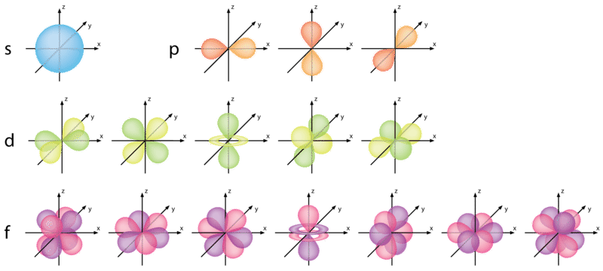
The images shown here are of simulations of probability density distributions of different electron states in the hydrogen atom. They represent where the electron is most likely to exist relative to the nucleus (Zukav 1979). There are different orbitals which can exist for a given atom and which a given electron can occupy. The four orbital types shown here are: (1) the spherically shaped s-orbital; (2) dumbbell-shaped p-orbitals (which are oriented in three different directions); (3) d-orbitals (which have five different possible orientations); and (4) f-orbitals (which have seven different possible orientations).

Quantum Numbers
We use a series of specific numbers, called quantum numbers, to describe the location of an electron in an associated atom. An electron in an atom or ion has four quantum numbers to describe its state. Think of them as important variables in an equation which describes the three-dimensional position of electrons in a given atom.

Principal Quantum Number
The principal quantum number, signified by (n), is the main energy level occupied by the electron. Electrons in orbitals with higher principal quantum numbers are, on average, further from the nucleus and higher in energy. Possible values for the principal quantum number include any positive whole number (e.g., 1, 2, 3, 4, 5, 6, ...). As we will see, the principal quantum number is related to the row in which an element appears on the periodic table.

Angular Momentum Quantum Number
The angular momentum quantum number, signified by (l), describes the general shape of the region occupied by an electron. The possible value(s) of l depend on the value of the principal quantum number n. The angular momentum quantum number can be any whole number between zero and (n-1). For example, if n = 2, l could be either 0 or 1.

Magnetic Quantum Number
The magnetic quantum number, signified by (m_{l}), describes the orientation of an orbital in space. For a given value of the angular momentum quantum number l, there are (2l + 1) possible values for m_{l}, which are determined as follows:
-l, (-l+1) ... 0 ... (+l – 1), + l
For example:
If n = 2
Then l = 0 or 1
for l = 0, m_{l} = 0
for l = 1, m_{l} = -1, 0, or +1
The Table below shows the possible magnetic quantum number values (m_{l}) for the corresponding angular momentum quantum number (l).
Relationships among Values of n,
n | Possible Values of l | Subshell Designation | Possible Values of m_{l} | Number of Orbitals in Subshell | Total Number of Orbitals in Shell
1 | 0 | 1s | 0 | 1 | 1
2 | 0  1 | 2s  2p | 0  1, 0, -1 | 1  3 | 4
3 | 0  1  2 | 3s  3p  3d | 0  1, 0, -1  2, 1, 0, -1, -2 | 1  3  5 | 9
4 | 0  1  2  3 | 4s  4p  4d  4f | 0  1, 0, -1  2, 1, 0, -1, -2  3, 2, 1, 0, -1, -2, -3 | 1  3  5  7 | 16

Spin Quantum Number
The spin quantum number describes the spin for a given electron. An electron can have one of two possible spin values, either +½ or -½. An electron cannot have zero spin. We also represent spin with arrows ↑ or ↓, and correspondingly, m_{s} values of +½ or -½ are sometimes referred to as “spin up” and “spin down” electrons. A single orbital can hold a maximum of two electrons, but only if they have opposite spins. Another way to say this is that no two electrons in an atom can have the same four quantum numbers. They cannot occupy the same orbital, designated by the first three numbers, and have the same spin, indicated by the final number.

s, p, d, and f Orbitals
The shapes corresponding to each value of l also go by different names, each designated by a single letter (chosen based on older analyses of atomic emission spectra). For example, an electron for which l = 0 is located in an s orbital, regardless of the value of its principal quantum number n. This orbital is spherical in shape, as seen in Figure below.
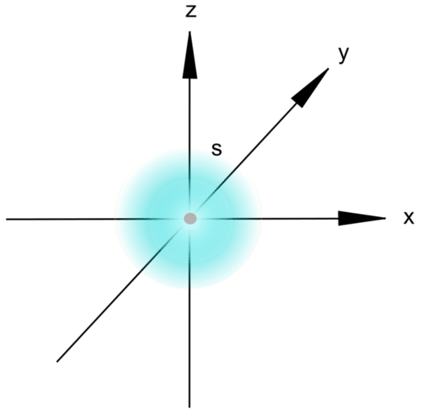
An s orbital
Electrons for which l = 1 are located in dumbbell-shaped p orbitals. Table above shows us that p orbitals can have three possible orientations (designated by three values for m_{l}), each of which is perpendicular to the two others in three-dimensional space (Figure below).
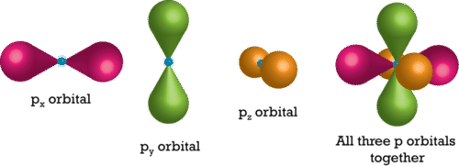
Three individual p orbitals are centered on the nucleus of the atom. This figure shows them both separately and together.
When l = 2, the possible m_{l} values include -2, -1, 0, +1, and +2, for a total of five d orbitals. The relative orientations for each of these orbitals are shown in Figure below. Note that even though one of the d orbitals appears to have a different shape than the others, it is still mathematically equivalent and exhibits the same properties (such as total energy) as the other d orbitals.
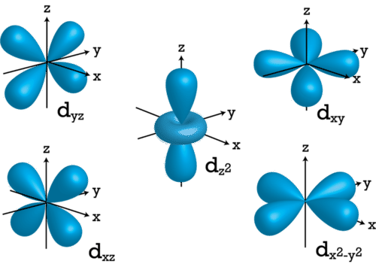
Relative geometry of the d orbitals
The most complex set of orbitals that we will encounter are the f orbitals. When l = 3, possible values for m_{l} include -3, -2, -1, 0, +1, +2, and +3, for a total of seven distinct orbitals. The relative orientations for each of these orbitals are shown in Figure below.
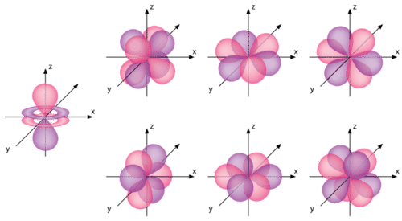
Relative geometry of the f orbitals

Rules for Determining Electron Configurations
Now that we know about some of the possible locations (orbitals) in an atom that can be occupied by electrons, how can we predict which orbitals will contain electrons and how many each will contain? The set of orbitals occupied by electrons in a given atom is referred to as its electron configuration. An electron configuration essentially provides a map of where each electron is likely to be located in a given atom. In the case of a free, electrically neutral atom, the atom is considered to be in a ground state. This means its electrons are in the lowest energy locations. Several rules can be used to determine the lowest energy locations of the various electrons in a free atom.

Aufbau Principle
To determine the lowest energy electron configuration for a given atom, it is first necessary to organize the atomic sublevels in order of increasing energy. Figure below shows the relative energies of various sublevels.
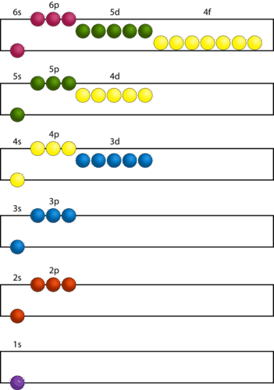
According to the Aufbau principle, all lower energy orbitals must be filled before electrons can be added to a higher energy orbital. The principal energy levels are color coded in this figure. Sublevels are grouped together by column, and each circle represents an orbital that is capable of holding two electrons.
The lowest energy sublevel is always the 1s sublevel, which consists of one orbital. The single electron of the hydrogen atom will occupy the 1s orbital when the atom is in its ground state. As we move on to atoms with more electrons, those electrons are sequentially added to the next lowest sublevels, first 2s, then 2p, then 3s, and so on. The Aufbau principle states that all lower energy orbitals must be filled before electrons can be added to a higher energy orbital. The Aufbau principle is sometimes referred to as the “building-up” principle. It is worth noting that, in reality, atoms are not built by adding protons and electrons one at a time. This method is merely a way for us to predict and understand the end result.
As seen in Figure above, the energies of the sublevels in different principal energy levels eventually begin to overlap. After the 3p sublevel, it would seem logical that the 3d sublevel should be the next lowest in energy. However, the 4s sublevel is slightly lower in energy than the 3d sublevel, so the 4s orbital fills first. After the 3d sublevel is filled, the next lowest sublevels are 4p, 5s, and 4d. Note that the 4f sublevel does not fill until just after the 6s sublevel. Figure below is a useful and simple aid for keeping track of the order in which electrons are first added to each atomic sublevel.
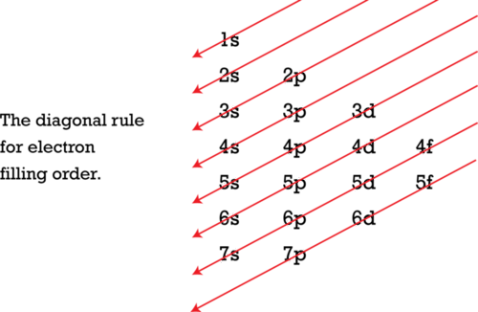
The Aufbau principle is illustrated in the diagram by following each red arrow in order from top to bottom: 1s, 2s, 2p, 3s, etc.

Pauli Exclusion Principle
As pointed out before, no two electrons in same atom can have the same set of four quantum numbers; this concept is referred to as the Pauli exclusion principle. If two electrons have the same three values for n, l, and m_{l}, they would be found in the same orbital. In order to maintain separate identities, two electrons in the same orbital would need to have different spin quantum numbers (m_{s}). Because there are only two possible spin quantum numbers, each orbital can hold a maximum of two electrons, each of which must have a different spin.

Hund’s Rule
Hund's rule states that, in a set of orbitals that are energetically equivalent, each orbital is occupied by a single electron before any orbital within the set is occupied by a second electron. Additionally, all electrons in singly occupied orbitals prefer to have the same spin quantum number. We will see more concrete examples of how this rule works below in our discussion of orbital filling diagrams.

Depicting Electron Configurations

Orbital Filling Diagrams
There are multiple ways to depict the electron configuration of a given atom. An orbital filling diagram provides a visual representation of the way in which an atom's electrons are distributed into various orbitals. Each orbital is shown as a single square (or circle), and orbitals within the same sublevel are drawn directly next to each other. Each sublevel is labeled by its principal quantum number and by its sublevel (which corresponds to a specific value of l). Electrons are indicated by arrows inside the circles. An arrow pointing upwards indicates one spin direction, while a downward pointing arrow indicates the other direction. The orbital filling diagrams for hydrogen, helium, and lithium are shown below.
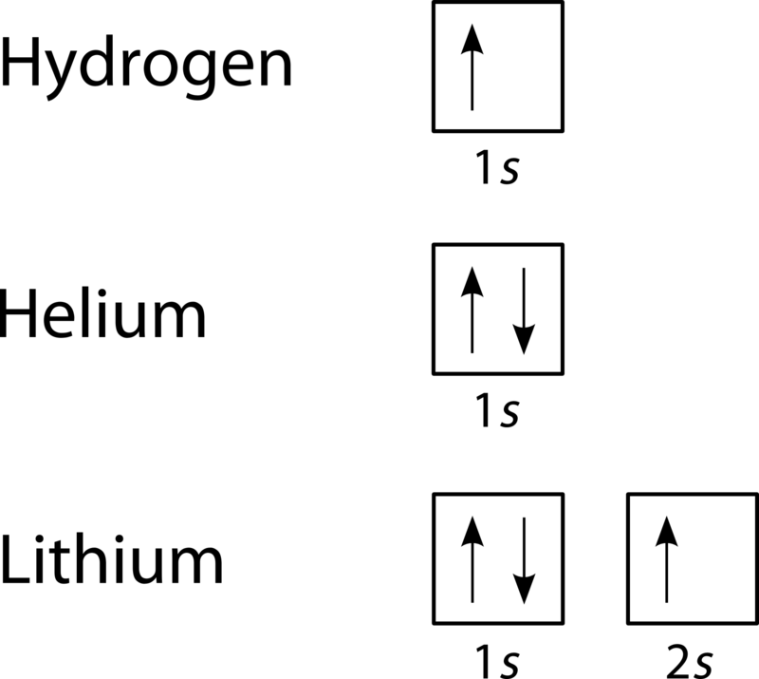
According to the Aufbau principle, sublevels and orbitals are filled with electrons in order of increasing energy. Since the s sublevel consists of just one orbital, the second electron simply pairs up with the first electron, as in helium. The next element, lithium, requires the use of the next available sublevel. The third electron must be placed in a 2s orbital, because the 1s orbital is completely filled.

Electron Configuration Notation
Electron configuration notation is a shorthand version of the information contained in orbital filling diagrams. The squares and arrows are eliminated and replaced with the name of each occupied sublevel and a superscript indicating the number of electrons present in that sublevel. For example, the configuration of a hydrogen atom is 1s¹, and the configuration of helium is 1s². Multiple occupied sublevels are placed one after another, so the electron configuration of lithium is written 1s²2s¹. The sum of all the superscripts in an electron configuration is equal to the number of electrons in that atom, which is in turn equal to its atomic number.

Noble Gas Notation
The elements that are found in the last column of the periodic table are an important group of elements called the noble gases. They include helium, neon, argon, krypton, xenon, and radon. For elements with large numbers of electrons, electron configurations can become quite long. The electron configuration of an atom can be abbreviated by using noble gas notation, in which the elemental symbol of the last noble gas prior to that atom is written first, followed by the configuration of the remaining electrons. Lithium can be used as an example to illustrate this method, even though its configuration (1s²2s¹) is not especially long. Because helium has a configuration of 1s², that portion of the configuration for neon can be replaced by the symbol for helium written in brackets, [He]. Now, the configuration for lithium can be written as [He]2s¹. This becomes more useful in the case of larger atoms. For example, the full electron configuration for cesium is 1s²2s²2p⁶3s²3p⁶4s²3d¹⁰4p⁶5s²4d¹⁰5p⁶6s¹. Using noble gas notation, this becomes [Xe]6s¹. Comparing this to the configuration of lithium, it becomes easy to see the similarity. Each of these elements has a configuration equivalent to a noble gas plus a single electron in an s orbital. This fundamental similarity causes the chemical properties of lithium and cesium to be quite similar. We will revisit this trend when we discuss the structure of the periodic table.

Filling the Orbitals with Electrons - The First 10 Elements

Hydrogen and Helium - The 1s Orbital
Now let's see how electrons are arranged for the first several elements. We start with hydrogen, which has only one electron. According to the Aufbau principle, this should be placed into the 1s orbital, which is the lowest energy orbital. For the 1s orbital, n = 1, l = 0, and m_{l} = 0, since that is the only possible m_{l} value when l = 0. Because there are no other electrons, it does not matter whether m_{s} is +½ or -½. The configuration of hydrogen is 1s¹, and possible quantum numbers for this electron would be the following:
Atomic Number: 1 Element: Hydrogen
n | l | m_{l} | m_{s} | Orbital Type
1 | 0 | 0 | +½ | 1s
Helium has two electrons. The lowest energy orbital (1s) has enough room to accommodate both, so the first three quantum numbers are the same for both electrons. However, in order to follow the Pauli exclusion principle, the spin of the second electron must be different from that of the first. One electron has a spin of +½ and the other electron has a spin of –½. Helium has a 1s² configuration, with two electrons in the 1s orbital. The quantum numbers for these two electrons are shown below:
Atomic Number: 2 Element: Helium
n | l | m_{l} | m_{s} | Orbital Type
1 | 0 | 0 | +½ | 1s
1 | 0 | 0 | -½ | 1s

Lithium and Beryllium - The 2s Orbital
Now that we have filled the 1s shell, we move to n = 2 and start to work on the second shell with lithium.
Atomic Number: 3 Element: Lithium
n | l | m_{l} | m_{s} | Orbital Name
1 | 0 | 0 | +½ | 1s
1 | 0 | 0 | -½ | 1s
2 | 0 | 0 | +½ | 2s
Lithium has a configuration of 1s²2s¹.
There is space for one more electron in the 2s orbital, so we give that second 2s electron a -½ spin.
Atomic Number: 4 Element: Beryllium
n | l | m_{l} | m_{s} | Orbital Name
1 | 0 | 0 | +½ | 1s
1 | 0 | 0 | -½ | 1s
2 | 0 | 0 | +½ | 2s
2 | 0 | 0 | -½ | 2s
Beryllium has a configuration of 1s²2s².

Boron Through Neon - The 2p Orbitals
Now that the 1s and 2s orbitals are filled, the next lowest energy orbitals are the three 2p orbitals. For p orbitals, l = 1, which means that m_{l} can have values of -1, 0, or +1. If there is only one electron in a set of p orbitals, it does not matter which of the possible values are used for m_{l} and m_{s}. One possible example is shown in the following table:
Atomic Number: 5 Element: Boron
n | l | m_{l} | m_{s} | Orbital Type
1 | 0 | 0 | +½ | 1s
1 | 0 | 0 | -½ | 1s
2 | 0 | 0 | +½ | 2s
2 | 0 | 0 | -½ | 2s
2 | 1 | -1 | +½ | 2p
Boron has a configuration of 1s²2s²2p¹.
Beginning with carbon, we start to see Hund’s rule come into play. The rule states that orbitals of equal energy are each occupied by one electron before any orbital is occupied by a second electron, and all electrons in singly occupied orbitals must have the same spin. So the sixth electron in carbon goes into another p orbital (with a different m_{l} value), and its value for m_{s} must match as many of the other 2p electrons as possible. A possible set of quantum numbers that satisfies these criteria is shown below:
Atomic Number: 6 Element: Carbon
n | l | m_{l} | m_{s} | Orbital Type
1 | 0 | 0 | +½ | 1s
1 | 0 | 0 | -½ | 1s
2 | 0 | 0 | +½ | 2s
2 | 0 | 0 | -½ | 2s
2 | 1 | -1 | +½ | 2p
2 | 1 | 0 | +½ | 2p
Carbon has a configuration of 1s²2s²2p².
Nitrogen has a third 2p electron, which should go into an orbital with the third possible value for m_{l}. Again, the m_{s} values should be the same for as many 2p electrons as possible, provided it does not violate the Pauli exclusion principle. In this case, all three can have the same spin value. Nitrogen has a configuration of 1s²2s²2p³.
Atomic Number: 7 Element: Nitrogen
n | l | m_{l} | m_{s} | Orbital Type
1 | 0 | 0 | +½ | 1s
1 | 0 | 0 | -½ | 1s
2 | 0 | 0 | +½ | 2s
2 | 0 | 0 | -½ | 2s
2 | 1 | -1 | +½ | 2p
2 | 1 | 0 | +½ | 2p
2 | 1 | +1 | +½ | 2p
Now that we have no more empty orbitals within this subshell, we need to start putting electrons in orbitals that are already partially occupied. For oxygen, one of the 2p orbitals will contain two electrons, while the others will still each have one. The electrons in the doubly occupied 2p orbital must have different spins to avoid violating the Pauli exclusion principle. Oxygen has a configuration of 1s²2s²2p⁴.
Atomic Number: 8 Element: Oxygen
n | l | m_{l} | m_{s} | Orbital Type
1 | 0 | 0 | +½ | 1s
1 | 0 | 0 | -½ | 1s
2 | 0 | 0 | +½ | 2s
2 | 0 | 0 | -½ | 2s
2 | 1 | -1 | +½ | 2p
2 | 1 | -1 | -½ | 2p
2 | 1 | 0 | +½ | 2p
2 | 1 | +1 | +½ | 2p
Adding another 2p electron gives us fluorine's configuration of 1s²2s²2p⁵.
Atomic Number: 9 Element: Fluorine
n | l | m_{l} | m_{s} | Orbital Type
1 | 0 | 0 | +½ | 1s
1 | 0 | 0 | -½ | 1s
2 | 0 | 0 | +½ | 2s
2 | 0 | 0 | -½ | 2s
2 | 1 | -1 | +½ | 2p
2 | 1 | -1 | -½ | 2p
2 | 1 | 0 | +½ | 2p
2 | 1 | 0 | -½ | 2p
2 | 1 | +1 | +½ | 2p
Once we reach neon, a noble gas, all of the 2p orbitals will be completely full. Neon has a configuration of 1s²2s²2p⁶. Any further electrons will need to go in the next highest energy orbital, which would be the 3s orbital.
Atomic Number: 10 Element: Neon
n | l | m_{l} | m_{s} | Orbital Type
1 | 0 | 0 | +½ | 1s
1 | 0 | 0 | -½ | 1s
2 | 0 | 0 | +½ | 2s
2 | 0 | 0 | -½ | 2s
2 | 1 | -1 | +½ | 2p
2 | 1 | -1 | -½ | 2p
2 | 1 | 0 | +½ | 2p
2 | 1 | 0 | -½ | 2p
2 | 1 | +1 | +½ | 2p
2 | 1 | +1 | -½ | 2p
Electron configurations and orbital filling diagrams for lithium through neon are provided in Figure below.
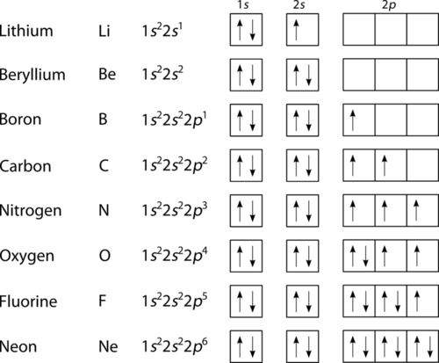
Electron configurations of lithium through neon.

Lesson Summary
- The locations where electrons are likely to be located around the nucleus are known as orbitals. Each orbital represents a three-dimensional region in which a given electron is most likely to be found.
- We use four quantum numbers to describe the location of an electron within an atom. The first three quantum numbers describe the orbital that the electron occupies, and the fourth indicates the relative spin of the electron.
- The principal quantum number, signified by (n), is the main energy level occupied by the electron.
- The angular momentum quantum number, signified by (l), describes the general shape of the region in which an electron is likely to be found (the shape of its orbital).
- The magnetic quantum momentum quantum number, signified by (m_{l}), describes the orientation of an orbital.
- The spin quantum number, signified by (m_{s}), describes the spin for a given electron. Possible values include +½ or -½; an electron cannot have zero spin. We also represent spin with arrows: ↑ (spin up) or ↓ (spin down).
- We can apply our knowledge of quantum numbers to describe the arrangement of electrons within an atom. We do this with something called electron configurations, which are effectively a map of the electrons for a given atom.

Lesson Review Questions
- State the four quantum numbers and the possible values they may have.
- Name the orbitals described by the following quantum numbers
  - n = 3, l = 0
  - n = 3, l = 1
  - n = 3, l = 2
  - n = 5, l = 0
- Give the n and lvalues for the following orbitals
  - 1s
  - 3s
  - 2p
  - 4d
  - 5f
- Place the following orbitals in order of increasing energy: 1s, 3s, 4s, 6s, 3d, 4f, 3p, 7s, 5d, 5p
- What are the possible m_{l}values for the following types of orbitals?
  - s
  - p
  - d
  - f
- How many possible orbitals are there for n =
  - 2
  - 4
- How many electrons can be accommodated by the full set of n = 4 orbitals?
- Tabulate all of the possible orbitals (by name, i.e. 4s) for n = 4 and give the three quantum numbers that define each orbital.
- Write electron configurations for the following atoms:
  - H
  - Li
  - N
  - F
  - Br

Further Reading / Supplemental Links
- Quantum Numbers and Electronic Configurations: http://chemed.chem.purdue.edu/genchem/topicreview/bp/ch6/quantum.html

