Honors Chemistry Final Exam
Review
Practice Questions:
1) What is the formula for chloric acid?

A HCl B HClO C HClO₂ D HClO₃
2) What volume of a 5.0 M NaOH solution is required to prepare 500.0mL of a 1.50M solution?

A 150mL B 0.067 mL C 1700 mL D 0.015 mL

3) How many grams of ice will melt at 0⁰C if the ice absorbs 420.0J of energy?
A 0.1860g B 0.7950g C 1.260g D 45.38g
4) What is the pH of a solution with a hydroxide concentration of [OH ⁻] = 1.0 x 10⁻⁸ M?

A 7 B 6 C 5 D 8

5) What is the concentration of phosphoric acid if it takes 25.0mL of 1.50M calcium hydroxide to
titrate 30.0mL of phosphoric acid?

- 1.25M B 0.833M C 1.88M D 2.7
6) What is the name of H₂SO₃ (aq)?

A hydrosulfuric acid B sulfurous acid
C hyposulfurous acid D sulfuric acid

7) Consider this reaction: 3H₂SO₄ + 2Al Al₂(SO₄)₃ + 3H₂

How many grams of aluminum sulfate should be produced if 7.35 grams of aluminum react with excess sulfuric acid?

A 46.6 g B 93.2 g C 1.16 g D 15.0 g
8) An aqueous solution of silver nitrate is added to an aqueous solution of iron (II) chloride. Which is the precipitate?

A AgCl B Fe(NO₃)₂ C AgNO₃ D FeCl₂

9) Which of the following would turn phenolphthalein pink?

A HCl B NaOH C NaCl D H₂SO₃
10) What products are formed when the metal lithium is added to hydrochloric acid?

A Li and H₂O B LiCl and H₂ C LiOH and H₂ D Li₂O and H₂O

11) How many grams of carbon dioxide gas occupy 44.8L at STP?

A 88.0 g B 2.0 g C 56.0 g D 22.8 g

12) If the temperature of a 2.0L container of gas at 45°C and 1.0 atm is increased to 75°C and
4.0L, what is the pressure?

A 0.30 atm B 0.46 atm C 0.55 atm D 0.83 atm

13) Analysis shows a compound to be, by mass, 43.8% N, 50.0% O, and 6.20% H. Which is the
empirical formula for the substance?

A N₃O₃H₆ B NH₂O C N₂OH₂ D N₂OH

14) What is the molarity of a solution containing 15.0 g of potassium fluoride dissolved in 1.50 L of
solution?

A 17.2 M B 5.81 M C 0.172 M D 10.0 M
15) 40.9 J of heat is applied to 2.0 grams of a gray colored metal which causes it’s tempeature to increase 20.0°C. What is the identity of that metal?
A aluminum B copper C iron D magnesium

16) Which of the following gases diffuses fastest?
A oxygen B nitrogen C sulfur D chlorine
17) Which point on the titration curve to the right represents the equivalence point?  A 1 B 3 C 5 D 6 | 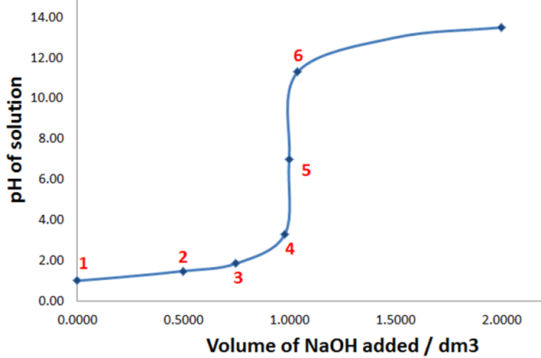
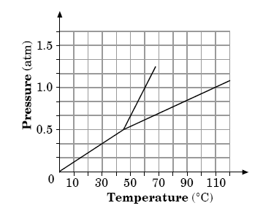
18) Consider the phase diagram to the right:

At what temperature does the triple
point occur?

A 60°C

B 110°C

C 37°C

D 45°C

19) A compound has an empirical formula of CH₂O and a molecular mass of 120 g/mol. What is the compound’s molecular formula?

A CH₂O B C₄H₈O₄ C C₆H₁₂O₆ D C₁₂H₂₂O₁₁

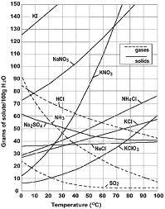
20) Which of the following substances is least
soluble at 80°C?

- NaNO₃
- KNO₃
- SO₂
- NH₄Cl

21) What is the pressure, in mmHg, exerted by a 1.35 mol sample of fluorine in a 3.50 L container
at 155°C ?

A 62.4 mmHg B 1377 mmHg C 10300 mmHg D 13.5 mmHg

22) Which of the following phase changes is exothermic?

A Sublimation B freezing C vaporizing D melting

23) Given the following reaction, which of the following stresses will cause the equilibrium to shift
to the right? N₂ (g) + 3H₂ (g) ⇌2NH₃(g)
A increase the concentration of ammonia B decrease the concentration of hydrogen

C increase the pressure D increase the volume

24) According to the diagram to the right,  which of the following statements is true  A the reaction is exothermic  B the energy of the reactants is  greater than the products  C the activation energy of the  forward direction is greater than  the reverse.  D a catalyst was used | 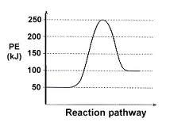

25) Which of the following equations represents the equilibrium equation for the
following reaction?

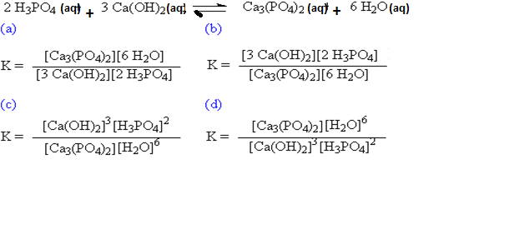
26) If you start with 5.5 grams of sodium fluoride, how many grams of magnesium fluoride will be produced?
Mg + 2 NaF → MgF₂ + 2 Na

27) A 15.00 gram sample of a sodium sulfate hydrate was found to contain 7.05 grams of water.
- Calculate the percent of water in the hydrate.

- Determine the formula of the hydrate & name it.

28) Use the diagrams below to answer questions 1-5
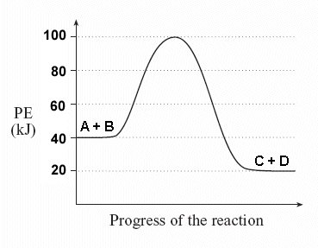 | - Is this potential energy diagram, endothermic or exothermic? __________________  - What is the energy of the activated complex? __________  - What is the energy of the reaction (ΔH)? __________  - What is the activation energy? _________  - The sign of ΔH is ______________ for endothermic reactions and ______________ for exothermic reactions.

- 29) How many grams of ammonium sulfate can be produced if 40.0 mol of H₂SO₄ react with excess NH₃
- according to the equation 2 NH₃(aq) + H₂SO₄(aq) → (NH₄)₂SO₄(aq)?

30) The volume of a gas is 350.0 mL when the pressure is 2.00 atm. At the same temperature, what is the pressure at which the volume of the gas is 1.0 L?

31) A sample of oxygen occupies 880 mL when the pressure is 760.00 mm Hg. At constant temperature, what volume does the gas occupy when pressure falls to 810.00 mm Hg?

32) A solution contains 85.0 g of NaNO₃ and has a volume of 950 mL. Find the molarity of the solution.

33) How many grams of NaOH are required to prepare 550. mL of a 0.450 M solution?

3 34) What is the pH of a solution with a [OH–] of 4.55 x 10^{–7} M?

2 35) What is the pH of a 0.0870 M KOH solution?

36) Find the percentage composition of each element for the following substances:
a. C₆H₁₂O₆
b. N₂O₄
c. lead(II) oxide

37) Copper (II) Sulfate is frequently found as a bluish compound, containing water. If you heated a sample of hydrated Copper (II) Sulfate that had a mass of 2.576 g, and drove off all the water, leaving you with Copper (II) Sulfate, the resulting compound had a mass of 1.646 g. Find:
- The mass of the water your drove off.
- The empirical formula of the hydrate.
- The name of the hydrate.

38) a) Lithium bromide and chloride react to form lithium chloride and bromide. Write and balance the equation.

b) Calculate the mass of lithium chloride produced when 1.04 g of lithium bromide reacts.

40) How many grams of CO₂ and H₂0 are formed from 8.36 mol of propane (C₃H₈)?
(hint: combustion)

41) Given the following equation answer the questions below:

4Al + 3O₂----> 2 Al₂O₃

- If I had 64.00 grams of O₂ how many grams of Al would be needed to react with that oxygen?

- If you wanted to produce 4.00 grams of Al₂O₃ how many grams of O₂ would be needed for the reaction?

42) If 4.95 g of ethylene (C₂H₄) are combusted with 3.25 g of oxygen.
a. What is the limiting reagent?
b. How many grams of CO₂ are formed?
c. How much excess reagent would be left over based off your answer above?

43) 43) Write the Equilibrium Expression for the reaction for each of the following:

  - N₂(g) + 3 H₂(g) ↔ 2 NH₃(g)
  - HC₂H₃O₂(aq) + H₂O(l) ↔ H₃O⁺(aq) + C₂H₃O₂⁻(aq)
  - Find the value for the equilibrium expression, Keq, shown in #25.a.
if [H₂] = 0.1 M, [N₂] = 0.06 M and [NH₃] = 6 M

44) A mixture of four gases (nitrogen, helium, argon, and oxygen) exerts a total pressure of 860 torr. Argon is 42% of the mixture. What is the partial pressure of argon?

45) How many moles of gas need to be removed from a balloon to decrease the volume from 500. mL to 175 mL if the balloon initially contains 7.25 moles of gas and the pressure and temperature remain constant?

