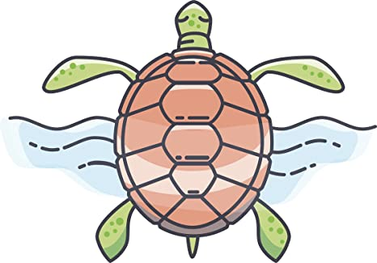
Oceanography Project Presentation Guidelines
*Due Date: Thursday, April 9th by 11:59PM (uploaded to Google Classroom)

Project Background:
For this project you will select an area of interest within Oceanography. From the topic choices provided please conduct your own research into an area that is intriguing to you. You need to make sure that you have emailed me your topic (you may need to specify exactly what you will be researching on within a general topic area), so that I may approve your idea and you can get started. An example of this would be if you wanted to research Ocean Exploration and you specified that you were going to research different submersibles utilized in oceanic research. Please email me by the end of the day on Wednesday, April 1st. The goal of this presentation is to investigate an area of interest within our unit Oceanography and effectively, as well as creatively, communicate your findings. I want you to take this opportunity to showcase your creativity. You will need to make sure you meet/exceed the requirements outlined below, however there are multiple ways to approach this assignment and I am thoroughly looking forward to what you all come up with! Have fun with this and get your parents involved to help you come up with some ideas on how you can actively engage your audience, which is primarily me, but I would love to share your presentations with each other to stay connected as a class!

Project Requirements:
- All presentations must be a minimum of 5 minutes and not exceed 7 minutes in length.
- Each presentation will need to be filmed, so your final product will be a video that you upload to me. Since we have been in our remote learning phase of school for almost a week now, you have been exposed to multiple methods of producing videos. You may use your phone, computer, etc., to film your presentation. I would highly recommend that you recruit some assistance with this task i.e. a parent, or sibling. You can record yourself speaking and simultaneously share your screen if you created a visual via powerpoint/ prezi through an app called Zoom. It is free and a great tool that could be used to assist you in creating your final presentation. Make sure you are communicating with your parents about these new apps/ tools of learning before you download/use anything. I personally use Zoom often. It is very easy to learn how to use.
- In addition to filming yourself presenting on your Oceanography research topic, you will need to have some type of visual represented in the presentation to illustrate the information you are conveying to your audience. As we have done in class before, you may create a Powerpoint, Prezi, poster, carry out a demonstration, etc. You need to have a creative element in addition to the information you will be sharing. There are so many ways to approach this and I want you to feel free to showcase your creativity throughout this presentation. A lot of you are very skilled in art, so maybe you could take this time to paint or draw an image that you feel will help enhance your presentation and truly illustrate various concepts you are trying to get across. Maybe you are a skilled builder and you create a model of something that represents a specific component of your research. A lot of you are also very theatrical and are skilled in creating different skits. Maybe create your own version of a documentary or live news broadcast that highlights your research. The possibilities are endless and if you want to discuss other ideas you may have feel free to reach out to me and we can talk about them.
- What I am looking for in your presentation is the following:
- Introduction: Name, Class Period, Topic
-Background: What is your topic? Why did you select it? Why is it important?
-Details of Topic: What are the most interesting facts about your topic that you want to share. Organization is key here. Make sure it is well thought out and your information that you are sharing flows well throughout the presentation. Pick specific areas to focus on and dive deeper into those areas with your research.
-Current Research: Make sure you are picking resources that are also current. Why is your topic relevant right now? Look up news articles that are current that may cover your topic and share those with us. Maybe even local news outlets that may have covered stories related to your topic. We are on the East Coast and are relatively close to the Atlantic Ocean, so there is a ton of information out there that would be great to share if you can.
-Most Important Unknowns or Questions: What are some questions that you had as you were conducting your research? Did you find any answers? What are some common questions people may have about your topic that you could answer throughout your presentation? Are there questions that cannot be answered yet? Are there areas within your topic researchers are still investigating?
-Visuals Must be Used in Presentation to Express Key Concepts- see #3
-References- you must have at least 5 different sources that you utilized to create your presentation. Please have a Reference page typed up (Times New Roman, 12pt font) and uploaded to Google Classroom- I will create an assignment folder on Google Classroom for you to upload it there. Please utilize Perdue Owl to help you create your Reference Page. We will use MLA format.
*Perdue Owl is a online database that helps with citing resources https://owl.purdue.edu/owl/purdue_owl.html

***You will also need to sign the CCS Honor Code, in addition to your parents signing it. This is a formal assessment and will count as a 100 point test grade. The Honor Code can be printed off, signed, and then uploaded to Google Classroom. I have attached that document to these guidelines for your convenience.

Earth and Environmental Science Mastin 2020

CCS HONOR CODE:

On my honor, I have neither given nor received help on this assessment. The work I am turning in is my own best effort.

Student Signature: _____________________ Date: _______________

Parent Signature: _______________________ Date: _______________

