Lesson Objectives
- Identify properties of metals.
- List properties of nonmetals.
- Describe metalloids.
- Relate valence electrons to reactivity of elements by class.

Vocabulary
- metal
- metalloid
- nonmetal
- valence electron

Introduction
Elements in different groups are lumped together in one of three classes, depending on their properties. The classes are metals, nonmetals, and metalloids. Knowing the class of an element lets you predict many of its properties. The video at the URL below is a good introduction to the classes.
http://www.youtube.com/watch?v=ZuQmionhkGU (2:04)

Metals
Metals are elements that are good conductors of electricity. They are the largest of the three classes of elements. In fact, most elements are metals. Look back at the modern periodic table (Figure above) in this chapter’s lesson "How Elements Are Organized." Find the metals in the table. They are all the elements that are color-coded blue. Examples include sodium (Na), silver (Ag), and zinc (Zn).
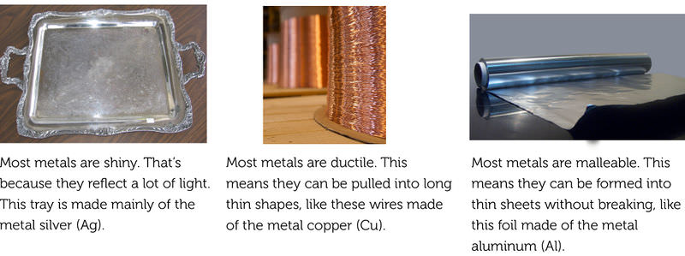
The three properties described here characterize most metals.
Metals have relatively high melting points, so almost all are solids at room temperature. The only exception is mercury (Hg), which is a liquid. Most metals are also good conductors of heat. That’s why they are used for cooking pots and stovetops. Metals have other characteristic properties as well. Most are shiny, ductile, and malleable. These properties are illustrated in Figure below. You can dig deeper into the properties of metals at this URL: http://www.bbc.co.uk/schools/gcsebitesize/science/add_gateway/periodictable/metalsrev1.shtml.

Nonmetals
Nonmetals are elements that do not conduct electricity. They are the second largest class of elements. Find the nonmetals in Figure above. They are all the elements on the right side of the table that are color-coded green. Examples of nonmetals include helium (He), carbon (C), and oxygen (O).
Nonmetals generally have properties that are the opposite of those of metals. They also tend to vary more in their properties than metals do. For example, nonmetals have relatively low boiling points, so many of them are gases at room temperature. But several nonmetals are solids, including carbon and phosphorus (P). One nonmetal, bromine (Br), is a liquid at room temperature.
Generally, nonmetals are also poor conductors of heat. In fact, they may be used for insulation. For example, the down filling in a down jacket is mostly air, which consists mainly of nitrogen (N) and oxygen (O). These nonmetal gases are poor conductors of heat, so they keep body heat in and cold air out. Solid nonmetals are dull rather than shiny. They are also brittle rather than ductile or malleable. You can see examples of solid nonmetals in Figure below. You can learn more about specific nonmetals with the interactive table at this URL: http://library.thinkquest.org/3659/pertable/nonmetal.html.
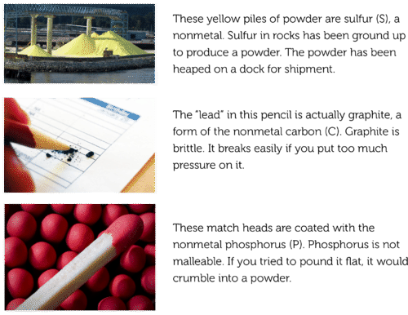
Unlike metals, solid nonmetals are dull and brittle.

Metalloids
Metalloids are elements that fall between metals and nonmetals in the periodic table. Just seven elements are metalloids, so they are the smallest class of elements. In Figure above, they are color-coded orange. Examples of metalloids include boron (B), silicon (Si), and germanium (Ge).
Metalloids have some properties of metals and some properties of nonmetals. For example, many metalloids can conduct electricity but only at certain temperatures. These metalloids are called semiconductors. Silicon is an example. It is used in computer chips. It is also the most common metalloid on Earth. It is shiny like a metal but brittle like a nonmetal. You see a sample of silicon in Figure below. The figure also shows other examples of metalloids. You can learn more about the properties of metalloids at this URL: http://library.thinkquest.org/3659/pertable/metaloid.html.
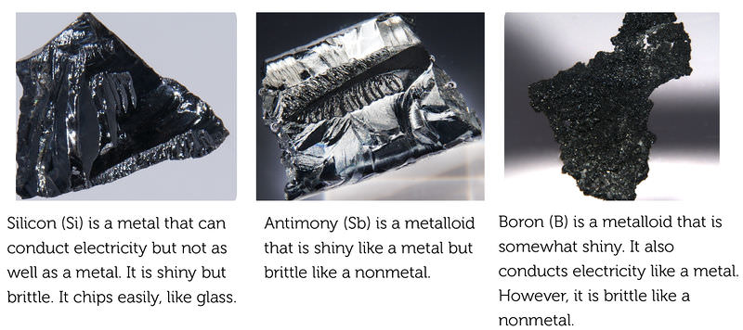
Metalloids share properties with both metals and nonmetals.

Classes of Elements and Electrons
From left to right across the periodic table, each element has one more proton than the element to its left. Because atoms are always electrically neutral, for each added proton, one electron is also added. Electrons are added first to the lowest energy level possible until that level is full. Only then are electrons added to the next higher energy level.

Electrons by Class
The increase in electrons across the periodic table explains why elements go from metals to metalloids and then to nonmetals from left to right across the table. Look at period 2 in Figure below as an example. Lithium (Li) is a metal, boron (B) a metalloid, and fluorine (F) and neon (Ne) are nonmetals. The inner energy level is full for all four elements. This level has just one orbital and can hold a maximum of two electrons. The outer energy level is a different story. This level has four orbitals and can hold a maximum of eight electrons. Lithium has just one electron in this level, boron has three, fluorine has seven, and neon has eight.
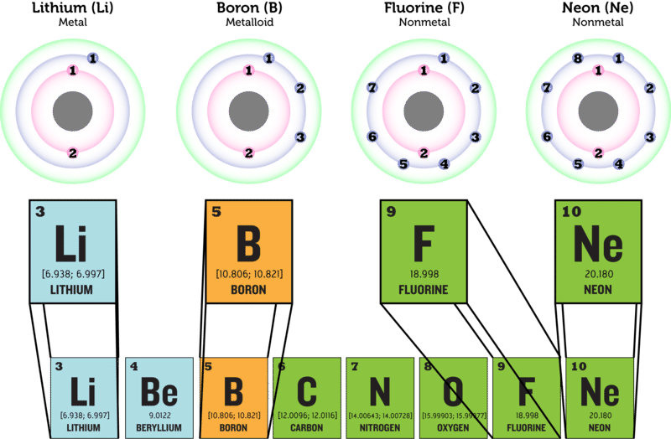
The number of electrons increases from left to right across each period in the periodic table. In period 2, lithium (Li) has the fewest electrons and neon (Ne) has the most. How do the numbers of electrons in their outer energy levels compare?

Valence Electrons and Reactivity
The electrons in the outer energy level of an atom are called valence electrons. It is valence electrons that are potentially involved in chemical reactions. The number of valence electrons determines an element’s reactivity, or how likely the element is to react with other elements. The number of valence electrons also determines whether the element can conduct electric current. That’s because electric current is the flow of electrons. Table below shows how these properties vary in elements from each class.
- Metals such as lithium have an outer energy level that is almost empty. They "want" to give up their few valence electrons so they will have a full outer energy level. As a result, metals are very reactive and good conductors of electricity.
- Metalloids such as boron have an outer energy level that is about half full. These elements need to gain or lose too many electrons for a full outer energy level to come about easily. As a result, these elements are not very reactive. They may be able to conduct electricity but not very well.
- Some nonmetals, such as bromine, have an outer energy level that is almost full. They "want" to gain electrons so they will have a full outer energy level. As a result, these nonmetals are very reactive. Because they only accept electrons and do not give them up, they do not conduct electricity.
- Other nonmetals, such as neon, have a completely full outer energy level. Their electrons are already in the most stable arrangement possible. They are unreactive and do not conduct electricity.
These examples show the relative reactivity of elements in the three classes.
Element | Description
Lithium  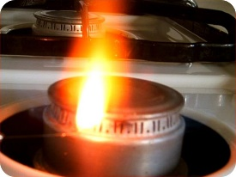 | Lithium (Li) is a highly reactive metal. It has just one electron in its outer energy level. Lithium reacts explosively with water (see picture). It can react with moisture on skin and cause serious burns.
Boron  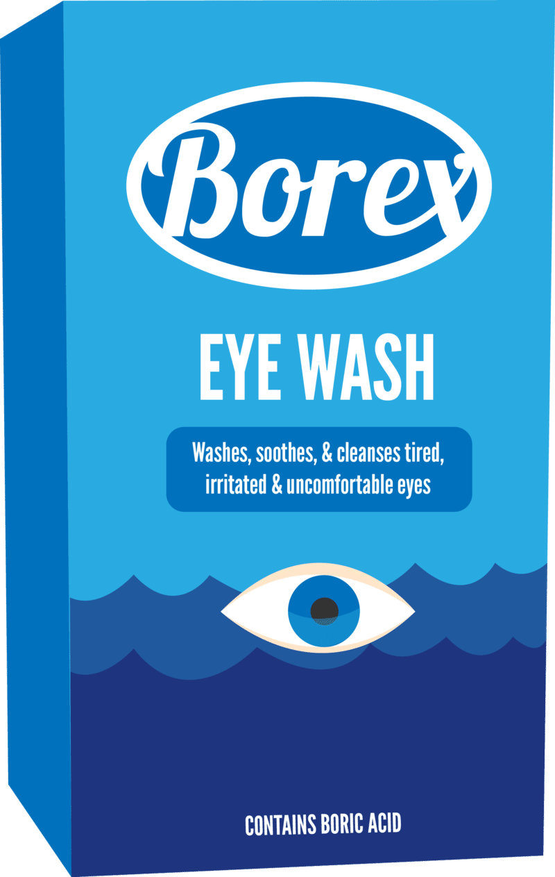 | Boron (B) is a metalloid. It has three valence electrons and is less reactive than lithium. Boron compounds dissolved in water form boric acid. Dilute boric acid is weak enough to use as eye wash.
Bromine | Bromine (Br) is an extremely reactive nonmetal. In fact, reactions with fluorine are often explosive, as you can see in the URL below.  http://www.youtube.com/watch?v=vtWp45Eewtw
Neon | Neon (Ne) is a nonmetal gas with a completely filled outer energy level. This makes it unreactive, so it doesn’t combine with other elements. Neon is used for lighted signs like this one. You can learn why neon gives off light at this link: http://www.scientificamerican.com/article.cfm?id=how-do-neon-lights-work

Lesson Summary
- Metals are elements that are good conductors of electricity. They are the largest class of elements. Many metals are shiny, ductile, and malleable. They are also good conductors of heat. Almost all metals are solids are room temperature.
- Nonmetals are elements that do not conduct electricity. They are the second largest class of elements. Nonmetals are also poor conductors of heat. The majority of nonmetals are gases. Solid nonmetals are dull and brittle.
- Metalloids are elements that have properties of both metals and nonmetals. Some can conduct electricity but only at certain temperatures. They may be shiny but brittle. All metalloids are solids at room temperature.
- Atoms of elements in different classes vary in their number of valence electrons. This explains their differences in reactivity and conductivity.

Lesson Review Questions

Recall
- What are metals? Name one example.
- Define nonmetal, and give an example.
- State one way that metalloids may be like metals and one way they may be like nonmetals.
- What are valence electrons?

Apply Concepts
- A mystery element is a dull, gray solid. It is very reactive with other elements. Classify the mystery element as a metal, nonmetal, or metalloid. Explain your answer.

Think Critically
- Create a Venn diagram for metals, metalloids, and nonmetals. The diagram should show which properties are different and which, if any, are shared among the three groups of elements.
- Relate number of valence electrons to reactivity of classes of elements.

Points to Consider
The number of valence electrons increases from left to right across each period of the periodic table. By the end of the period, the outer energy level is full. Moving on to the next period of the table, electrons are added to the next higher energy level. This happens in each row of the periodic table.
- How do you think the number of valence electrons compares in elements within the same column (group) of the periodic table?
- How might this be reflected in the properties of elements within a group?

