Lesson Objectives
- Identify hydrogen and alkali metals.
- Describe alkaline Earth metals.
- List properties of transition metals.
- Identify groups containing metalloids.
- Give properties of halogens.
- Describe noble gases.

Vocabulary
- alkali metal
- alkaline Earth metal
- halogen
- noble gas
- transition metal

Introduction
Elements in the same column, or group, of the periodic table have the same number of valence electrons in their outer energy level. This gives them many similar properties. The rest of this chapter describes properties of the different groups of elements. You can watch a video about the groups at this link: http://www.khanacademy.org/video/groups-of-the-periodic-table?playlist=Chemistry.

Group 1: Hydrogen and Alkali Metals
All the elements in group 1 have just one valence electron, so they are highly reactive. Group 1 is shown in Figure below. At the top of this group is hydrogen (H), which is a very reactive, gaseous nonmetal. It is the most common element in the universe.
All the other elements in group 1 are alkali metals. They are the most reactive of all metals, and along with the elements in group 17, the most reactive elements. Because alkali metals are so reactive, they are only found in nature combined with other elements. The alkali metals are soft. Most are soft enough to cut with a knife. They are also low in density. Some of them even float on water. All are solids at room temperature. You can see a video demonstrating the reactivity of alkali metals with water at this URL: http://www.youtube.com/watch?v=uixxJtJPVXk (2:22).
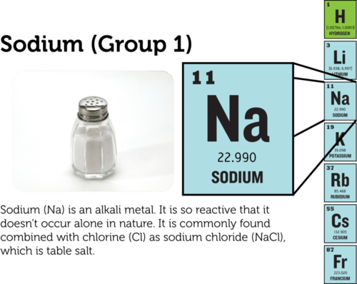
In group 1 of the periodic table, all the elements except hydrogen (H) are alkali metals.

Group 2: Alkaline Earth Metals
The alkaline Earth metals include all the elements in group 2 (see Figure below). These metals have just two valence electrons, so they are very reactive, although not quite as reactive as the alkali metals. In nature, they are always found combined with other elements. Alkaline Earth metals are silvery grey in color. They are harder and denser than the alkali metals. All are solids at room temperature.
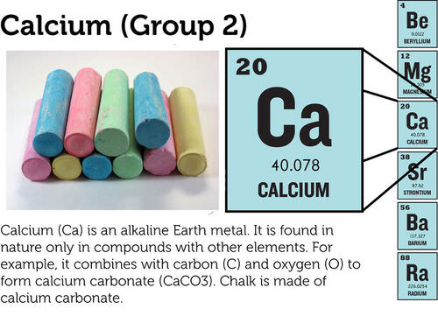
The alkaline Earth metals make up group 2 of the periodic table.

Groups 3-12: Transition Metals
Groups 3–12 of the periodic table contain transition metals (see Figure below). Transition metals have more valence electrons and are less reactive than metals in the first two metal groups. The transition metals are shiny. Many are silver colored. They tend to be very hard, with high melting and boiling points. All except mercury (Hg) are solids at room temperature.
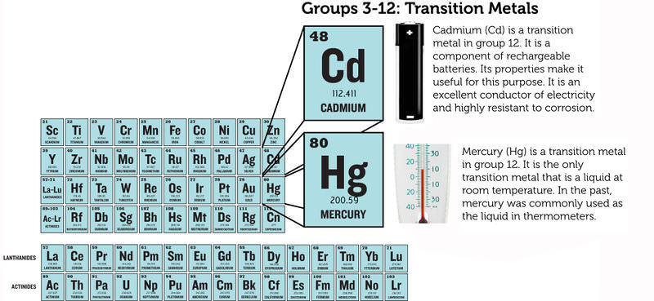
All the elements in groups 3–12 are transition metals.
Transition metals include the elements that are placed below the periodic table. Those that follow lanthanum (La) are called lanthanides. They are all shiny, relatively reactive metals. Those that follow Actinium (Ac) are called actinides. They are all radioactive metals. This means they are unstable. They break down into different, more stable elements. You can read more about radioactive elements in the chapter Nuclear Chemistry. Many of the actinides do not occur in nature but are made in laboratories.

Groups 13-16: Groups Containing Metalloids
Groups 13–16 each contain one or more metalloids. These groups are shown in Figure below.
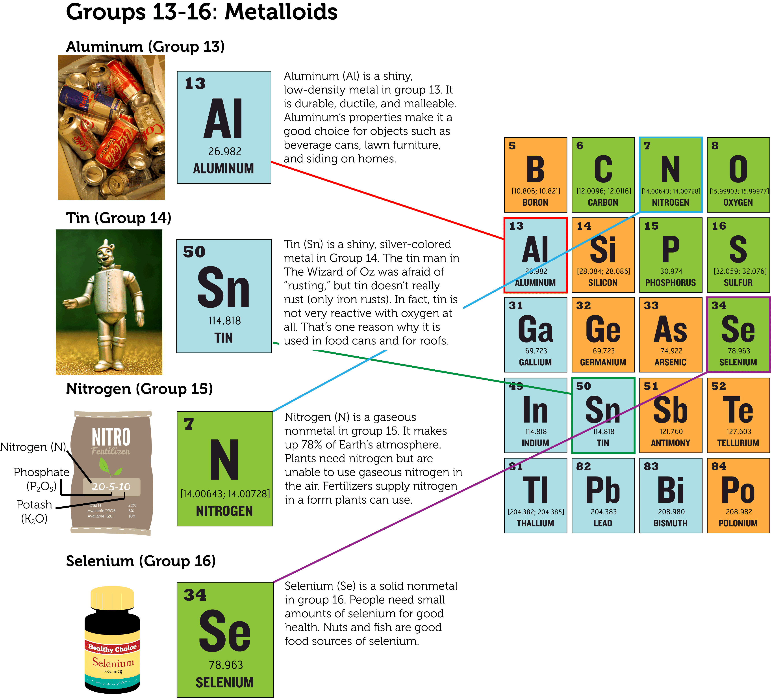
These groups each contain one or more metalloids.
- Group 13 is called the boron group. The only metalloid in this group is boron (B). The other four elements are metals. All group 13 elements have three valence electrons and are fairly reactive. All are solids at room temperature.
- Group 14 is called the carbon group. Carbon (C) is a nonmetal. The next two elements are metalloids, and the final two are metals. All the elements in the carbon group have four valence electrons. They are not very reactive. All are solids at room temperature.
- Group 15 is called the nitrogen group. The first two elements in this group are nonmetals. These are followed by two metalloids and one metal. All the elements in the nitrogen group have five valence electrons, but they vary in their reactivity. Nitrogen (N) in not reactive at all. Phosphorus (P), in contrast, is quite reactive. In fact, it is found naturally only in combination with other substances. Nitrogen is a gas at room temperature. The other group 15 elements are solids.
- Group 16 is called the oxygen group. The first three elements in this group are nonmetals. They are followed by one metalloid and one metal. All the elements in the oxygen group have six valence electrons, and all are reactive. Oxygen (O), for example, readily reacts with metals to form compounds such as rust. Oxygen is a gas at room temperature. The other four elements in group 16 are solids.

Group 17: Halogens
Elements in group 17 are called halogens (see Figure below). They are highly reactive nonmetals with seven valence electrons. The halogens react violently with alkali metals, which have one valence electron. The two elements combine to form a salt. For example, the halogen chlorine (Cl) and the alkali metal sodium (Na) react to form table salt, or sodium chloride (NaCl). The halogen group includes gases, liquids, and solids. For example, chlorine is a gas at room temperature, bromine (Br) is a liquid, and iodine (I) is a solid. You can watch a video demonstrating the reactivity of halogens at this URL: http://www.youtube.com/watch?v=mY7o28-l_WU&feature=related.
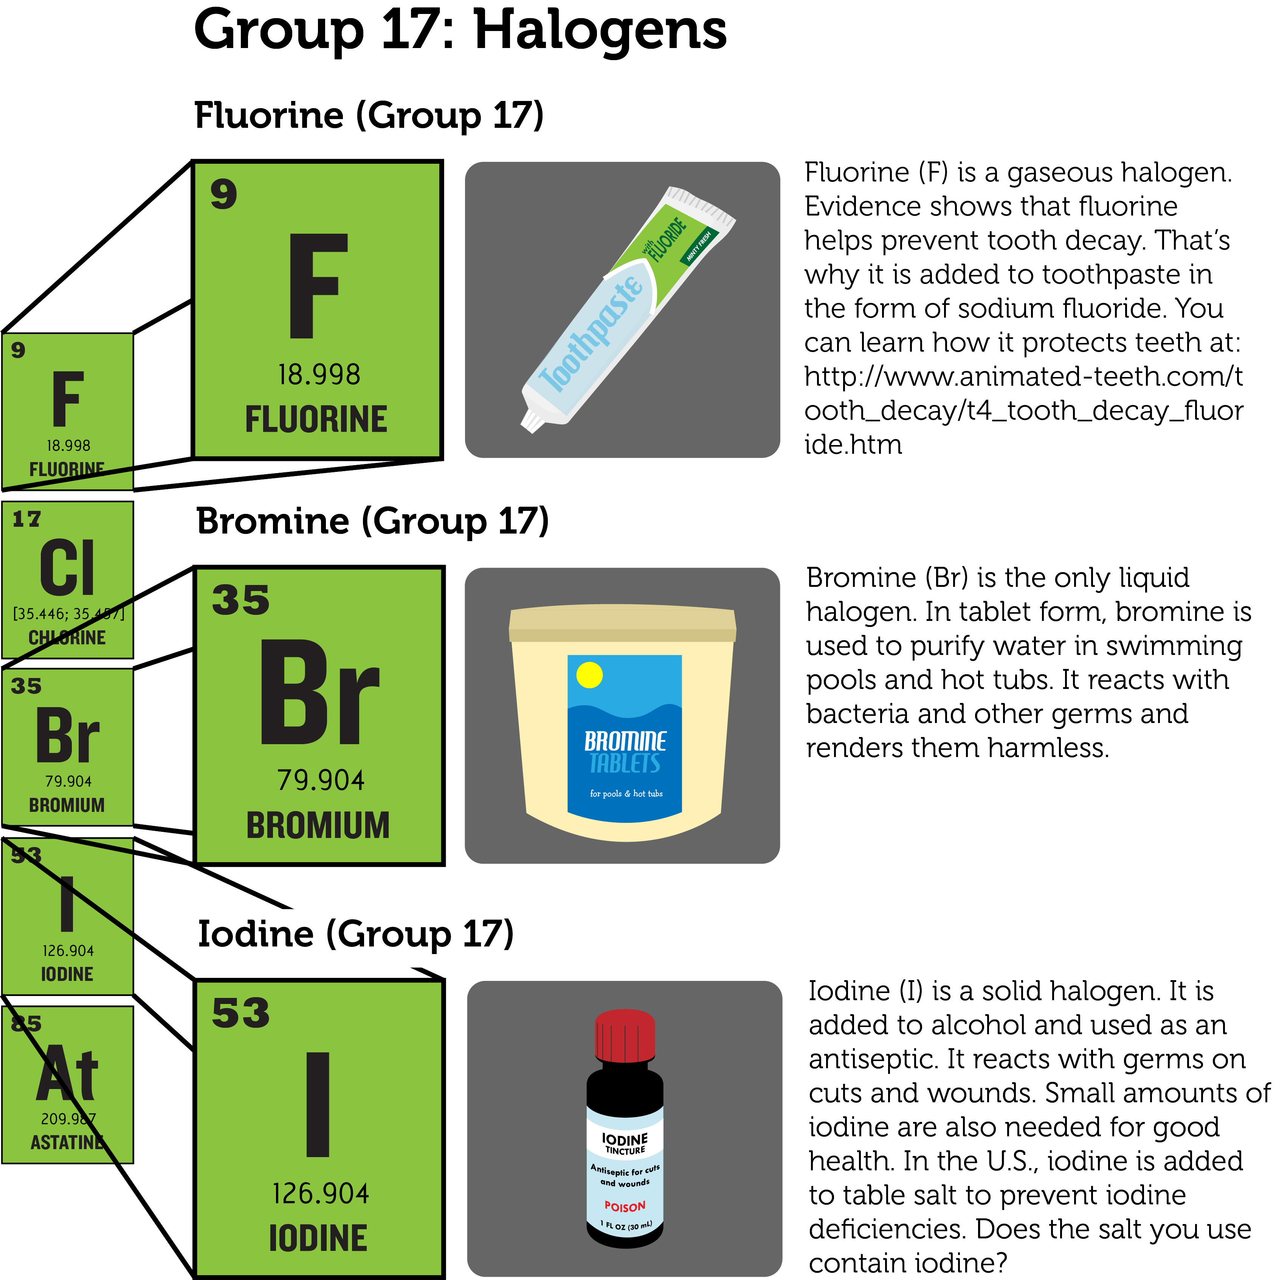
Group 17 consists of the nonmetals called halogens.

Group 18: Noble Gases
Group 18 elements are nonmetals called noble gases (see Figure below). They are all colorless, odorless gases. Their outer energy level is also full, so they are the least reactive elements. In nature, they seldom combine with other substances. For a short video about the noble gases and their properties, go to this URL: http://www.youtube.com/watch?v=QLrofyj6a2s (1:17).
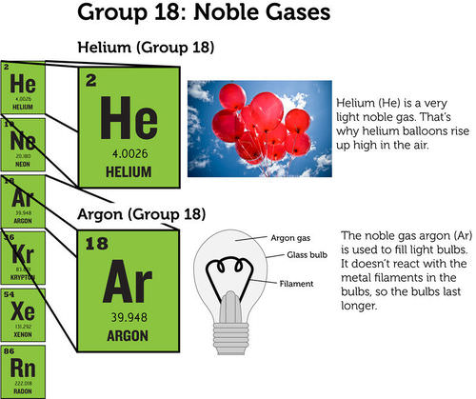
Noble gases include helium and argon.

Lesson Summary
- Group 1 of the periodic table consists of hydrogen and the alkali metals. Hydrogen is a very reactive nonmetal. The alkali metals are the most reactive metals.
- Group 2 consists of the alkaline Earth metals. They are very reactive but less so than the alkali metals.
- Groups 3–12 contain transition metals. They are less reactive than metals in groups 1 and 2.
- Groups 13–16 each contain at least one metalloid. They also contain metals and/or nonmetals. Elements in these groups vary in reactivity and other properties.
- Group 17 contains halogens. They are highly reactive nonmetals.
- Group 18 consists of noble gases. They are unreactive and rarely combine with other elements.

Lesson Review Questions

Recall
- What are alkali metals? What is one example?
- Identify an alkaline Earth metal. How reactive is it?
- Which element is the only transition metal that is a liquid at room temperature?
- In which groups of the periodic table would you find metalloids?
- State why halogens are highly reactive.
- Describe noble gases.

Apply Concepts
- Assume you have a sample of an unknown element. At room temperature, it is a soft solid. You cut a small piece from the sample with a knife and drop the piece into a container of water. It bursts into flames. Which group of the periodic table does the unknown element belong in?

Think Critically
- Both hydrogen (H) and helium (He) are gaseous nonmetals. Why are they placed on opposite sides of the periodic table?

Points to Consider
Reactive elements combine easily with other elements. This explains why they usually exist in nature in compounds rather than in pure form.
- How do you think elements join together to form compounds?
- Do you think this might vary from one group of elements to another?
For Table above,
- Lithium: User:Chemicalinterest/Wikimedia Commons. http://commons.wikimedia.org/wiki/File:Lithium_burning.JPG. Public Domain.
- Boron: Christopher Auyeung. CC BY-NC 3.0. CK-12 Foundation.
- Neon: Andy Wright. http://www.flickr.com/photos/rightee/4356950/. CC BY 2.0.

