States of Matter

- Read the paragraph below. Underline any solids, circle any liquids, and box any gases

The water begins to bubble. Steam rises from the pot. You want your hot chocolate, but it is too hot to drink. You don’t want to wait for it to cool down. So, you add an ice cube. You watch the ice melt in the hot liquid until the drink is just the right temperature.
- What are the names for the three different states of water?
- In the space below, draw what you think the particles of the three states of water look like.
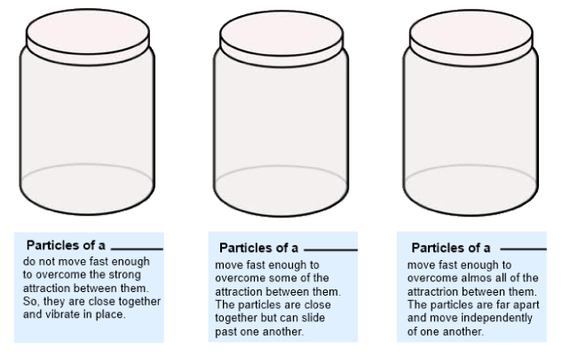
- A solid is a state of matter that has a ________________ shape and volume.
- The attraction between a solid is __________ than the attraction between the particles of the same substance in a liquid or gaseous state.
- The only type of movement particles in a solid do is _____________.
- A liquid is a state of matter that has a ______________ volume but takes the ________ of its container.
- Solids vibrate, but the motion of a liquid could be describe as the particles ___________ past each other.
- A gas is a state of matter that has no definite _________ or _________.
- The particles of a gas have ______ attraction between them than do particles of the same substance in the solid or liquid state.
- One property that all particles of matter have in common is they
  - Never move in solids
  - Only move in gases
  - Move constantly
  - None of the above

