13.4 Changes of State

Lesson Objectives
- Interpret heating and cooling curves.
- Know the terms for the six different changes of state.
- Describe the general features of a phase diagram, including the triple point and the critical point.

Lesson Vocabulary
- critical pressure
- critical temperature
- phase diagram
- triple point

Check Your Understanding

Recalling Prior Knowledge
- What are the names for the various changes of state that matter can undergo?
- How does an increase in pressure affect the nature of a gas?
Throughout this chapter, we have examined the nature of solids, liquids, and gases using the kinetic-molecular theory. In this lesson, we look more closely at changes of state and the temperatures and pressures at which those changes occur.

Heating Curves
Imagine that you have a block of ice that is at a temperature of −30°C, well below its melting point. The ice is in a closed container. As heat is steadily added to the ice block, the water molecules will begin to vibrate faster and faster as they absorb kinetic energy. Eventually, when the ice has warmed to 0°C, the added energy will start to break apart the hydrogen bonding that keeps the water molecules in place when it is in the solid form. As the ice melts, its temperature does not rise. All of the energy that is being put into the ice goes into the melting process and not into any increase in temperature. During the melting process, the two states—solid and liquid—are in equilibrium with one another. If the system were isolated at that point and no energy was allowed to enter or leave, the ice-water mixture at 0°C would remain. Temperature is always constant during a change of state.
Continued heating of the water after the ice has completely melted will now increase the kinetic energy of the liquid molecules, and the temperature will once again begin to rise. Assuming that the atmospheric pressure is standard, the temperature will rise steadily until it reaches 100°C. At this point, the added energy from the heat will cause the liquid to begin to vaporize. As with the previous state change, the temperature will remain steady at 100°C while the intermolecular hydrogen bonds are being broken and water molecules pass from the liquid to the gas state. Once all the liquid has completely boiled, continued heating of the steam (remember, the container is closed) will increase its temperature above 100°C.
The experiment described above can be summarized in a graph called a heating curve (Figure below).
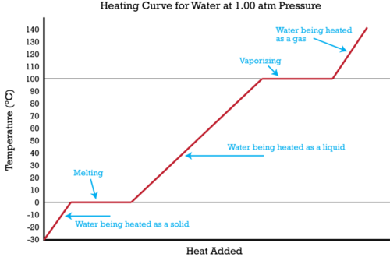
In the heating curve of water, temperature is plotted against the amount of energy that has been added in the form of heat. The temperature is constant during changes of state, as indicated by the plateaus on the curve.
The change of state behavior for any substance can be represented with a heating curve of this type. The melting and boiling points of the substance can be determined by the horizontal plateaus on the curve. Of course, other substances would have melting and boiling points that are different from those of water. One exception to this exact form for a heating curve would be for a substance such as carbon dioxide, which sublimes rather than melts at standard pressure. The heating curve for carbon dioxide would have only one plateau, at its sublimation temperature.
The entire experiment could also be run in reverse. Steam above 100°C could be steadily cooled down to 100°C, at which point it would condense to liquid water. The water could then be cooled to 0°C, at which point continued cooling would freeze the water to ice. The ice could then be cooled to some point below 0°C. This could be diagrammed in a cooling curve that would be the reverse of the heating curve.

Summary of State Changes
All of the changes of state that occur between solid, liquid, and gas are summarized in the diagram below (Figure below). Freezing is the opposite of melting, and both represent the equilibrium between the solid and liquid states. Condensation is the opposite of vaporization, and both represent the equilibrium between the liquid and gas states. Deposition is the opposite of sublimation, and both represent the equilibrium between the solid and gas states.
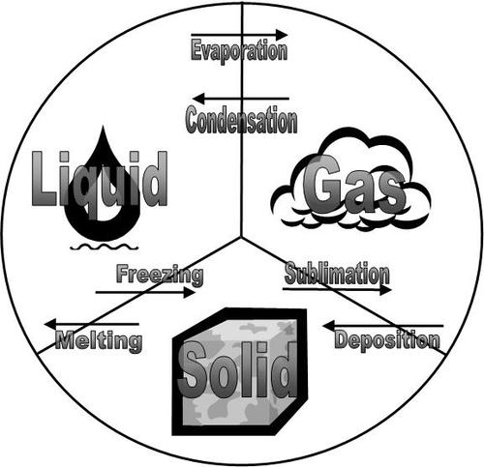
The solid, liquid, and gas states are shown with the terms for the changes of state that occur between each pair.
You can experiment with pressure, temperature, and phases using this simulation http://www.pbs.org/wgbh/nova/physics/states-of-matter.html. A document to guide you with questions can be found at https://docs.google.com/open?id=0B_ZuEGrhVEfMWkJQQkE4TFlrS28.
A video experiment of boiling t-butanol can be seen at http://www.youtube.com/watch?v=HSvFBANRlyk&feature=player_embedded.

Phase Diagrams
The relationships among the solid, liquid, and vapor (gas) states of a substance can be shown as a function of temperature and pressure in a single diagram. A phase diagram is a graph showing the conditions of temperature and pressure under which a substance exists in the solid, liquid, and gas phases. Examine the general phase diagram shown below (Figure below). In each of the three colored regions of the diagram, the substance is in a single state (or phase). The dark lines that act as the boundary between those regions represent the conditions under which the two phases are in equilibrium.
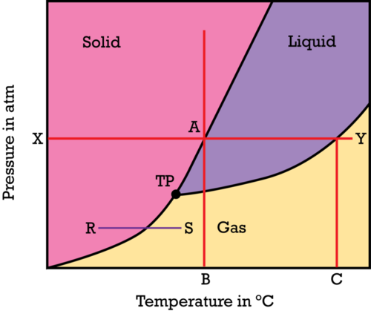
General phase diagram, which shows the state (phase) of a substance as a function of its temperature and pressure.
Find the X on the pressure axis, and presume that the value of X is the standard pressure of 1 atm. As one moves left to right across the red line, the temperature of the solid substance is being increased while the pressure remains constant. When point A is reached, the substance melts. Because we are looking at data corresponding to the standard pressure of 1 atm, temperature B on the horizontal axis represents the normal melting point of the substance. Moving farther to the right, the substance boils at point Y, so point C on the horizontal axis represents the normal boiling point of the substance. As the temperature increases at a constant pressure, the substance changes from solid to liquid to gas.
Start right above point B on the temperature axis and follow the red line vertically. At very low pressure, the particles of the substance are far apart from one another and the substance is in the gas state. As the pressure is increased, the particles of the substance are forced closer and closer together. Eventually the particles are pushed so close together that attractive forces cause the substance to condense into the liquid state. Continually increasing the pressure on the liquid will eventually cause the substance to solidify. For the majority of substances, the solid state is denser than the liquid state, so putting a liquid under great pressure will cause it to turn into a solid.
The line segment R−S represents the process of sublimation, where the substance changes directly from a solid to a gas. At a sufficiently low pressure, the liquid phase does not exist. The point labeled TP is called the triple point. The triple point is the only temperature/pressure pairing at which the solid, liquid, and vapor states of a substance can all coexist at equilibrium. The phase diagram for water is shown below (Figure below).
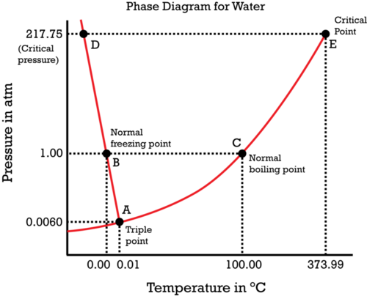
Phase diagram for water.
Notice one key difference between the general phase diagram and the phase diagram for water. In water’s diagram, the slope of the line between the solid and liquid states is negative rather than positive. The reason is that water is an unusual substance in that its solid state is less dense than the liquid state. Ice floats in liquid water. Therefore, a pressure change has the opposite effect on those two phases. If ice is relatively near its melting point, it can be changed into liquid water by the application of pressure. The water molecules are actually closer together in the liquid phase than they are in the solid phase.
The phenomenon of melting ice by pressure can be demonstrated in a relatively simple experiment. In the following video, a thin metal wire is weighted at both ends and placed over a block of ice. The pressure of the wire on the ice melts it. When the pressure is removed, the water refreezes.
http://www.youtube.com/watch?v=2mimXPlD2OU (2:16)
Refer again to water’s phase diagram. Notice point E, labeled the critical point. What does that mean? At 373.99°C, particles of water in the gas phase are moving very, very rapidly. At any temperature higher than that, the gas phase cannot be made to liquefy, no matter how much pressure is applied to the gas. The critical temperature (T_{c}) of a substance is the highest temperature at which the substance can possibly exist as a liquid. The critical pressure (P_{c}) is the pressure that must be applied to the gas at the critical temperature in order to turn it into a liquid. For water, the critical pressure is very high, 217.75 atm. The critical point is the intersection point of the critical temperature and the critical pressure.
An animated heating curve that will help you understand how molecules look at each section of a heating curve can be viewed at http://www.dlt.ncssm.edu/core/Chapter11-Thermochemistry/Chapter11-Animations/HeatingCurve.html.

Lesson Summary
- Changes of state can be described by a heating curve, which shows how a substance progresses from solid to liquid to gas as energy is added. The temperature of the substance is always constant during a change of state.
- A phase diagram shows the states of matter of a substance as a function of temperature and pressure. Boundaries between regions on a phase diagram represent the conditions at which equilibrium exists between two states.
- The triple point represents the one combination of temperature and pressure where all three states of matter can coexist at equilibrium. The critical point occurs at the highest temperature at which the substance is capable of existing in the liquid state.

Lesson Review Questions

Reviewing Concepts
- Explain why a liquid stays at a constant temperature while it is boiling, even though heat is still being added.
- Does a change in pressure have a greater effect on the melting point of a substance or on the boiling point of the substance?
- For each change of state listed below, state whether energy is being added or being removed from the substance.
  - freezing
  - sublimation
  - vaporization
  - condensation
  - melting
  - deposition
- Referring to the terms in question three, match each change of state with its reverse process.
- What would it mean if the line between the solid and liquid regions of a phase diagram was exactly vertical?
- Explain the significance of the critical point.

Problems
- Shown below is the phase diagram for carbon dioxide, CO₂. 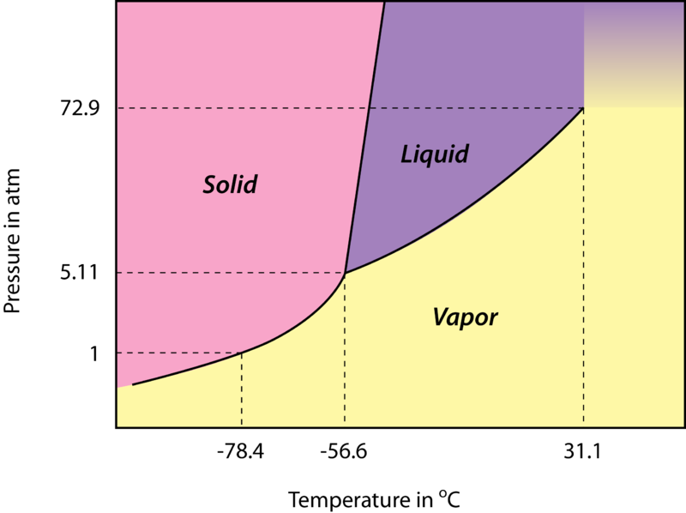
  - What are the temperature and pressure at the triple point of CO₂?
  - What state is CO₂ in at a temperature of −20°C and a pressure of 1 atm?
  - Explain, using the diagram, why CO₂ sublimes rather than melts at standard pressure.
  - What phase change occurs when CO₂ at 70 atm is heated from −60°C to 10°C?
  - What phase change occurs when CO₂ at −80°C is pressurized from 0.2 atm to 4 atm?
  - What are the temperature and pressure at the critical point of CO₂?
  - Is solid CO₂ more dense or less dense than liquid CO₂?

Further Reading / Supplemental Links
- Phase Diagrams, (http://www.wisc-online.com/objects/ViewObject.aspx?ID=GCH6304)
- Phase Diagrams of Pure Substances, (http://www.chemguide.co.uk/physical/phaseeqia/phasediags.html)
Frostbite Theater has several exciting demonstrations of state changes that use liquid nitrogen:
- If you like balloons, you can watch Instant Liquid Nitrogen Balloon Party at http://education.jlab.org/frost/instant_balloon.html. The explanation for this phenomenon is demonstrated at http://education.jlab.org/frost/balloon.html.
- Shattering Flowers http://education.jlab.org/frost/carnation.html.
- Giant Koosh Ball http://education.jlab.org/frost/giant_koosh_ball.html
- Watch an egg melt after it was frozen with liquid nitrogen at http://education.jlab.org/frost/freeze_egg.html.
- Which is colder - dry ice or liquid nitrogen? http://education.jlab.org/frost/dry_ice_and_nitrogen.html.
- Watch Shattering Pennies at http://education.jlab.org/frost/pennies_and_nitrogen.html.
- Watch liquid nitrogen freeze at http://education.jlab.org/frost/freeze_liquid_nitrogen.html.
- Watch when happens when Starburst candy is frozen in liquid nitrogen at http://education.jlab.org/frost/starburst.html.
- Is antifreeze any match for liquid nitrogen? http://education.jlab.org/frost/antifreeze.html.
- Watch Liquid Nitrogen and the Tea Kettle Mystery at http://education.jlab.org/frost/live_tea_kettle.html.
- Watch Squealing Dry Ice at http://education.jlab.org/frost/squealing_dry_ice.html.
The phase changes of dry ice are exciting! Watch a video demonstration at http://www.youtube.com/watch?v=wTMmGaS4r-k&feature=player_embedded.
A video experiment demonstrating the cooling curve of t-butanol is located at http://www.youtube.com/watch?v=-2IldvWaIE8&feature=player_embedded. The accompanying document for this lab can be downloaded from http://www.dlt.ncssm.edu/core/Chapter11-Thermochemistry/Chapter11-Labs/CoolingCurve_t-butanol_web_01-02.doc.

Points to Consider
The description of a gas, according to the kinetic-molecular theory, is that gas particles are very far apart from one another and so the particles do not interact with each other. This description leads to a set of mathematical relationships concerning the amount, temperature, pressure, and volume of a gas sample.
- How would the pressure of an enclosed sample of gas be affected if more gas were added?
- How would the pressure of an enclosed sample of gas be affected if the temperature were increased?
- How would the pressure of an enclosed sample of gas be affected if the volume of the container were increased?

