Unit 9: Motion- Acceleration

Lesson Objectives
- Define acceleration.
- Explain how to calculate acceleration.
- Describe velocity-time graphs.

Lesson Vocabulary
- acceleration

Introduction
Imagine the thrill of riding on a roller coaster like the one in Figure below. The coaster crawls to the top of the track and then flies down the other side. It also zooms around twists and turns at breakneck speeds. These changes in speed and direction are what make a roller coaster ride so exciting. Changes in speed or direction are called acceleration.
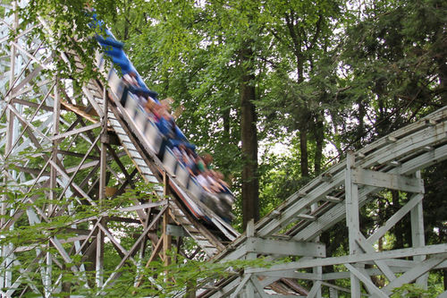
[Figure 1]
Did you ever ride on a roller coaster like this one? It’s called the "Blue Streak" for a reason. As it speeds around the track, it looks like a streak of blue.

Defining Acceleration
Acceleration is a measure of the change in velocity of a moving object. It shows how quickly velocity changes. Acceleration may reflect a change in speed, a change in direction, or both. Because acceleration includes both a size (speed) and direction, it is a vector.
People commonly think of acceleration as an increase in speed, but a decrease in speed is also acceleration. In this case, acceleration is negative. Negative acceleration may be called deceleration. A change in direction without a change in speed is acceleration as well. You can see several examples of acceleration in Figure below.
[Figure 2]
How is velocity changing in each of these pictures?
If you are accelerating, you may be able to feel the change in velocity. This is true whether you change your speed or your direction. Think about what it feels like to ride in a car. As the car speeds up, you feel as though you are being pressed against the seat. The opposite occurs when the car slows down, especially if the change in speed is sudden. You feel yourself thrust forward. If the car turns right, you feel as though you are being pushed to the left. With a left turn, you feel a push to the right. The next time you ride in a car, notice how it feels as the car accelerates in each of these ways. For an interactive simulation about acceleration, go to this URL: http://phet.colorado.edu/en/simulation/moving-man.

Calculating Acceleration
Calculating acceleration is complicated if both speed and direction are changing. It’s easier to calculate acceleration when only speed is changing. To calculate acceleration without a change in direction, you just divide the change in velocity (represented by Δv) by the change in time (represented by Δt). The formula for acceleration in this case is:
Acceleration=ΔvΔt
Consider this example. The cyclist in Figure below speeds up as he goes downhill on this straight trail. His velocity changes from 1 meter per second at the top of the hill to 6 meters per second at the bottom. If it takes 5 seconds for him to reach the bottom, what is his acceleration, on average, as he flies down the hill?
Acceleration=ΔvΔt=6 m/s−1 m/s5 s=5 m/s5 s=1 m/s1 m=1 m/s2
In words, this means that for each second the cyclist travels downhill, his velocity increases by 1 meter per second (on average). The answer to this problem is expressed in the SI unit for acceleration: m/s2 ("meters per second squared").
[Figure 3]
Gravity helps this cyclist increase his downhill velocity.
You Try It!
Problem: Tranh slowed his skateboard as he approached the street. He went from 8 m/s to 2 m/s in a period of 3 seconds. What was his acceleration?

Velocity-Time Graphs
The acceleration of an object can be represented by a velocity–time graph like the one in Figure below. A velocity-time graph shows how velocity changes over time. It is similar to a distance-time graph except the y−axis represents velocity instead of distance. The graph in Figure below represents the velocity of a sprinter on a straight track. The runner speeds up for the first 4 seconds of the race, then runs at a constant velocity for the next 3 seconds, and finally slows to a stop during the last 3 seconds of the race.
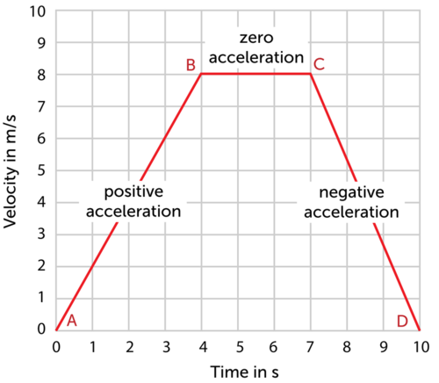
[Figure 4]
This graph shows how the velocity of a runner changes during a 10-second sprint.
In a velocity-time graph, acceleration is represented by the slope of the graph line. If the line slopes upward, like the line between A and B in Figure above, velocity is increasing, so acceleration is positive. If the line is horizontal, as it is between B and C, velocity is not changing, so acceleration is zero. If the line slopes downward, like the line between C and D, velocity is decreasing, so acceleration is negative. You can review the concept of acceleration as well as other chapter concepts by watching the musical video at this URL: http://www.youtube.com/watch?v=4CWlNoNpXCc.

Lesson Summary
- Acceleration is a measure of the change in velocity of a moving object. It shows how quickly velocity changes and whether the change is positive or negative. It may reflect a change in speed, a change in direction, or both.
- To calculate acceleration without a change in direction, divide the change in velocity by the change in time.
- The slope of a velocity-time graph represents acceleration.

Lesson Review Questions

Recall
- What is acceleration?
- How is acceleration calculated?
- What does the slope of a velocity-time graph represent?

Apply Concepts
- The velocity of a car on a straight road changes from 0 m/s to 6 m/s in 3 seconds. What is its acceleration?

Think Critically
- Because of the pull of gravity, a falling object accelerates at 9.8 m/s². Create a velocity-time graph to represent this motion.

Points to Consider
Acceleration occurs when a force is applied to a moving object.
- What is force? What are some examples of forces?
- What forces might change the velocity of a moving object? (Hint: Read the caption to Figure above.)

