Unit 9: Motion- Distance and Direction

Lesson Objectives
- Define motion, and relate it to frame of reference.
- Describe how to measure distance.
- Explain how to represent direction.

Lesson Vocabulary
- distance
- frame of reference
- motion
- vector

Introduction
You can see several examples of people or things in motion in Figure below. You can probably think of many other examples. You know from experience what motion is, so it may seem like a straightforward concept. Motion can also be defined simply, as a change in position. But if you think about examples of motion in more depth, you’ll find that the idea of motion is not quite as simple and straightforward as it seems.
[Figure 1]
These are just a few examples of people or things in motion. If you look around, you’re likely to see many more.

Frame of Reference
Assume that a school bus, like the one in Figure below, passes by as you stand on the sidewalk. It’s obvious to you that the bus is moving. It is moving relative to you and the trees across the street. But what about to the children inside the bus? They aren’t moving relative to each other. If they look only at the other children sitting near them, they will not appear to be moving. They may only be able to tell that the bus is moving by looking out the window and seeing you and the trees whizzing by.
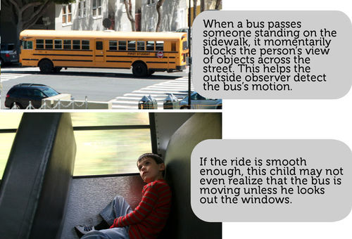
[Figure 2]
To a person outside the bus, the bus’s motion is obvious. To children riding the bus, its motion may not be as obvious.
This example shows that how we perceive motion depends on our frame of reference. Frame of reference refers to something that is not moving with respect to an observer that can be used to detect motion. For the children on the bus, if they use other children riding the bus as their frame of reference, they do not appear to be moving. But if they use objects outside the bus as their frame of reference, they can tell they are moving. What is your frame of reference if you are standing on the sidewalk and see the bus go by? How can you tell the bus is moving? The video at the URL below illustrates other examples of how frame of reference is related to motion.
http://www.youtube.com/watch?v=7FYBG5GSklU (6:45)

Distance
Did you ever go to a track meet like the one pictured in Figure below? Running events in track include 100-meter sprints and 2000-meter races. Races are named for their distance. Distance is the length of the route between two points. The length of the route in a race is the distance between the starting and finishing lines. In a 100-meter sprint, for example, the distance is 100 meters.
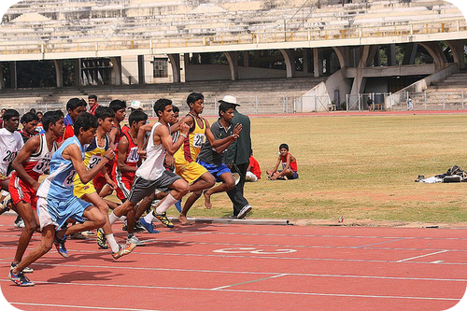
[Figure 3]
These students are running a 100-meter sprint.

SI Unit for Distance
The SI unit for distance is the meter (1 m = 3.28 ft). Short distances may be measured in centimeters (1 cm = 0.01 m). Long distances may be measured in kilometers (1 km = 1000 m). For example, you might measure the distance a frog’s tongue moves in centimeters and the distance a cheetah moves in kilometers.

Using Maps to Measure Distance
Maps can often be used to measure distance. Look at the map in Figure below. Find Mia’s house and the school. You can use the map key to directly measure the distance between these two points. The distance is 2 kilometers. Measure it yourself to see if you agree.
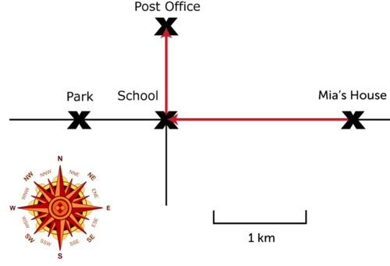
[Figure 4]
This map shows the routes from Mia’s house to the school, post office, and park.

Direction
Things don’t always move in straight lines like the route from Mia’s house to the school. Sometimes they change direction as they move. For example, the route from Mia’s house to the post office changes from west to north at the school (see Figure above). To find the total distance of a route that changes direction, you must add up the distances traveled in each direction. From Mia’s house to the school, for example, the distance is 2 kilometers. From the school to the post office, the distance is 1 kilometer. Therefore, the total distance from Mia’s house to the post office is 3 kilometers.
You Try It!
Problem: What is the distance from the post office to the park in Figure above?
Direction is just as important as distance in describing motion. For example, if Mia told a friend how to reach the post office from her house, she couldn’t just say, "go 3 kilometers." The friend might end up at the park instead of the post office. Mia would have to be more specific. She could say, "go west for 2 kilometers and then go north for 1 kilometer." When both distance and direction are considered, motion is a vector. A vector is a quantity that includes both size and direction. A vector is represented by an arrow. The length of the arrow represents distance. The way the arrow points shows direction. The red arrows in Figure above are vectors for Mia’s route to the school and post office. If you want to learn more about vectors, watch the videos at these URLs:
- http://www.youtube.com/watch?v=B-iBbcFwFOk (5:27)
- http://www.youtube.com/watch?v=tSOz3xaHKLs
You Try It!
Problem: Draw vectors to represent the route from the post office to the park in Figure above.

Lesson Summary
- Motion is a change of position. The perception of motion depends on a person’s frame of reference.
- Distance is the length of the route between two points. The SI unit for distance is the meter (m).
- Direction is just as important as distance in describing motion. A vector is a quantity that has both size and direction. It can be used to represent the distance and direction of motion.

Lesson Review Questions

Recall
- Define motion.
- What is distance?
- Describe how a vector represents distance and direction.

Apply Concepts
- In Figure above, what is the distance from Mia’s house to the park?
- Draw vectors to represent the following route from point A to point B:
  - Starting at point A, go 2 km east.
  - Then go 1 km south.
  - Finally, go 3 km west to point B.

Think Critically
- Explain how frame of reference is related to motion.

Points to Consider
A snail might travel 2 centimeters in a minute. A cheetah might travel 2 kilometers in the same amount of time. The distance something travels in a given amount of time is its speed.
- How could you calculate the speed of a snail or cheetah?
- Speed just takes distance and time into account. How might direction be considered as well?

