Unit 9: Motion- Speed and Velocity

Lesson Objectives
- Outline how to calculate the speed of a moving object.
- Explain how velocity differs from speed.

Lesson Vocabulary
- speed
- velocity

Introduction
Did you ever play fast-pitch softball? If you did, then you probably have some idea of how fast the pitcher throws the ball. For a female athlete, like the one in Figure below, the ball may reach a speed of 120 km/h (about 75 mi/h). For a male athlete, the ball may travel even faster. The speed of the ball makes it hard to hit. If the ball changes course, the batter may not have time to adjust the swing to meet the ball.
[Figure 1]
In fast-pitch softball, the pitcher uses a "windmill" motion to throw the ball. This is a different technique than other softball pitches. It explains why the ball travels so fast.

Speed
Speed is an important aspect of motion. It is a measure of how fast or slow something moves. It depends on how far something travels and how long it takes to travel that far. Speed can be calculated using this general formula:
speed=distance/ time
A familiar example is the speed of a car. In the U.S., this is usually expressed in miles per hour (see Figure below). If your family makes a car trip that covers 120 miles and takes 3 hours, then the car’s speed is:
speed=120 mi/ 3h= 40 mi/h
The speed of a car may also be expressed in kilometers per hour (km/h). The SI unit for speed is meters per second (m/s).
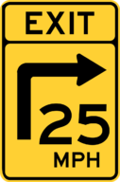
[Figure 2]
Speed limit signs like this one warn drivers to reduce their speed on dangerous roads.

Instantaneous vs. Average Speed
When you travel by car, you usually don’t move at a constant speed. Instead you go faster or slower depending on speed limits, traffic, traffic lights, and many other factors. For example, you might travel 65 miles per hour on a highway but only 20 miles per hour on a city street (see Figure below). You might come to a complete stop at traffic lights, slow down as you turn corners, and speed up to pass other cars. The speed of a moving car or other object at a given instant is called its instantaneous speed. It may vary from moment to moment, so it is hard to calculate.
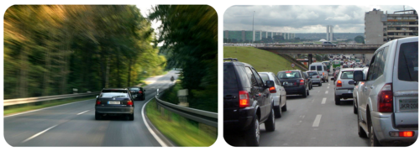
[Figure 3]
Cars race by in a blur of motion on an open highway but crawl at a snail’s pace when they hit city traffic.
It’s easier to calculate the average speed of a moving object than the instantaneous speed. The average speed is the total distance traveled divided by the total time it took to travel that distance. To calculate the average speed, you can use the general formula for speed that was given above. Suppose, for example, that you took a 75-mile car trip with your family. Your instantaneous speed would vary throughout the trip. If the trip took a total of 1.5 hours, your average speed for the trip would be:
average speed=75 mi/ 1.5 h= 50 mi/h
You can see a video about instantaneous and average speed and how to calculate them at this URL: http://www.youtube.com/watch?v=a8tIBrj84II (7:18).
You Try It!
Problem: Terri rode her bike very slowly to the top of a big hill. Then she coasted back down the hill at a much faster speed. The distance from the bottom to the top of the hill is 3 kilometers. It took Terri 15 minutes to make the round trip. What was her average speed for the entire trip?

Distance-Time Graphs
The motion of an object can be represented by a distance-time graph like the one in Figure below. A distance-time graph shows how the distance from the starting point changes over time. The graph in Figure below represents a bike trip. The trip began at 7:30 AM (A) and ended at 12:30 PM (F). The rider traveled from the starting point to a destination and then returned to the starting point again.
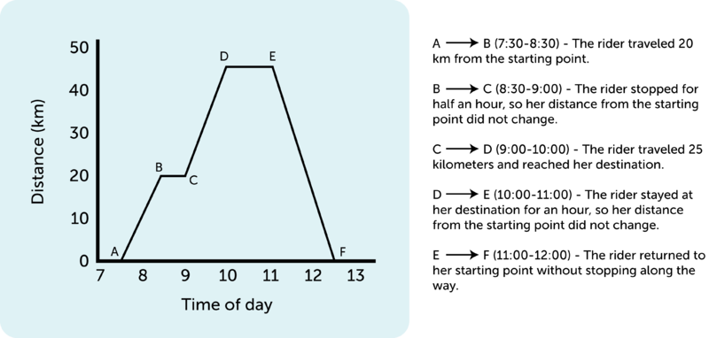
[Figure 4]
This graph shows how far a bike rider is from her starting point at 7:30 AM until she returned at 12:30 PM.

Slope Equals Speed
In a distance-time graph, the speed of the object is represented by the slope, or steepness, of the graph line. If the line is straight, like the line between A and B in Figure above, then the speed is constant. The average speed can be calculated from the graph. The change in distance (represented by Δd) divided by the change in time (represented by Δt):
speed=Δd/ Δt
For example, the speed between A and B in Figure above is:
speed=Δd/ Δt= 20 km−0 km/ 8:30−7:30 h= 20 km/ 1h= 20 km/h
If the graph line is horizontal, as it is between B and C, then the slope and the speed are zero:
speed=Δd/ Δt=20 km−20 km/ 9:00−8:30 h= 0 km/ 0.5 h= 0 km/h
You Try It!
Problem: In Figure above, calculate the speed of the rider between C and D.

Calculating Distance from Speed and Time
If you know the speed of a moving object, you can also calculate the distance it will travel in a given amount of time. To do so, you would use this version of the general speed formula:
distance=speed×time
For example, if a car travels at a speed of 60 km/h for 2 hours, then the distance traveled is:
distance=60 km/h×2 h=120 km
You Try It!
Problem: If Maria runs at a speed of 2 m/s, how far will she run in 60 seconds?

Velocity
Speed tells you only how fast an object is moving. It doesn’t tell you the direction the object is moving. The measure of both speed and direction is called velocity. Velocity is a vector that can be represented by an arrow. The length of the arrow represents speed, and the way the arrow points represents direction. The three arrows in Figure below represent the velocities of three different objects. Vectors A and B are the same length but point in different directions. They represent objects moving at the same speed but in different directions. Vector C is shorter than vector A or B but points in the same direction as vector A. It represents an object moving at a slower speed than A or B but in the same direction as A. If you’re still not sure of the difference between speed and velocity, watch the cartoon at this URL: http://www.youtube.com/watch?v=mDcaeO0WxBI (2:10).
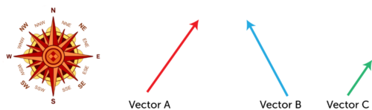
[Figure 5]
These vectors show both the speed and direction of motion.
In general, if two objects are moving at the same speed and in the same direction, they have the same velocity. If two objects are moving at the same speed but in different directions (like A and B in Figure above), they have different velocities. If two objects are moving in the same direction but at a different speed (like A and C in Figure above), they have different velocities. A moving object that changes direction also has a different velocity, even if its speed does not change.

Lesson Summary
- Speed is a measure of how fast or slow something moves. It depends on the distance traveled and how long it takes to travel that distance. The average speed of an object is calculated as the change in distance divided by the change in time.
- Velocity is a measure of both speed and direction. It is a vector that can be represented by an arrow. Velocity changes with a change in speed, a change in direction, or both.

Lesson Review Questions

Recall
- What is speed? How is it calculated?
- Define velocity.

Apply Concepts
- Sam ran a 2000-meter race. He started at 9:00 AM and finished at 9:05 AM. He started out fast but slowed down toward the end. Calculate Sam’s average speed during the race.
- Create a distance-time graph to represent a typical trip from your home to school or some other route you travel often. You may estimate distances and times.

Think Critically
- Explain how a distance-time graph represents speed.
- Compare and contrast speed and velocity.
- Is speed a vector? Why or why not?

Points to Consider
In this chapter, you read that the speed of a moving object equals the distance traveled divided by the time it takes to travel that distance. Speed may vary from moment to moment as an object speeds up or slows down. In the next lesson, "Acceleration," you will learn how to measure changes in speed over time.
- Do you know what a change in speed or direction is called?
- Why might measuring changes in speed or direction be important?

